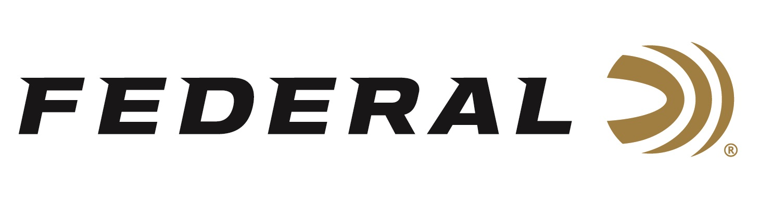

FOR IMMEDIATE RELEASE

Federal Introduces Premium HST 10mm Auto Load

ANOKA, Minnesota – February 22, 2019 – Federal has combined the ultimate self-defense bullet and cartridge in its new Federal Premium 10mm Auto HST load. Shipments have been delivered to dealers.

Full-power loading makes the most of the HST bullet design, providing large, consistent expansion, optimum penetration and superior terminal performance. Its specially designed hollow point won't plug while passing through a variety of barriers, and the bullet jacket and core hold together to provide nearly 100 percent weight retention through even the toughest materials.

Features & Benefits
- 1130 fps muzzle velocity
- Specially designed 200-grain hollow point expands reliably through a variety of barriers
- Expanded diameter and weight retention produce the desired penetration for self-defense situations without over penetrating
- Superior performance in FBI test protocol used by law enforcement officials to assess and select duty ammunition
- Bullet nose profile, nickel-plated case and Federal’s unique primer provide the ultimate in function and reliability in semi-automatic handguns

Part No. / Description / MSRP
P10HST1S / 10mm Auto 200-grain HST 1130 fps 20-count / $34.95

For more information on Federal ammunition, visit www.federalpremium.com.

Press Release Contact: JJ Reich
Senior Communications Manager - Ammunition
E-mail: VistaPressroom@VistaOutdoor.com

About Federal Ammunition
Federal, headquartered in Anoka, MN, is a brand of Vista Outdoor Inc., an outdoor sports and recreation company. From humble beginnings nestled among the lakes and woods of Minnesota, Federal Ammunition has evolved into one of the world's largest producers of sporting ammunition. Beginning in 1922, founding president, Charles L. Horn, paved the way for our success. Today, Federal carries on Horn's vision for quality products and service with the next generation of outdoorsmen and women. We maintain our position as experts in the science of ammunition production. Every day we manufacture products to enhance our customers' shooting experience while partnering with the conservation organizations that protect and support our outdoor heritage. We offer thousands of options in our Federal Premium and Federal lines—it’s what makes us the most complete ammunition company in the business and provides our customers with a choice no matter their pursuit.

Federal is part of Vista Outdoor Inc., an outdoor sports and recreation corporation. For news and information on Vista Outdoor Inc., visit www.vistaoutdoor.com.

###

