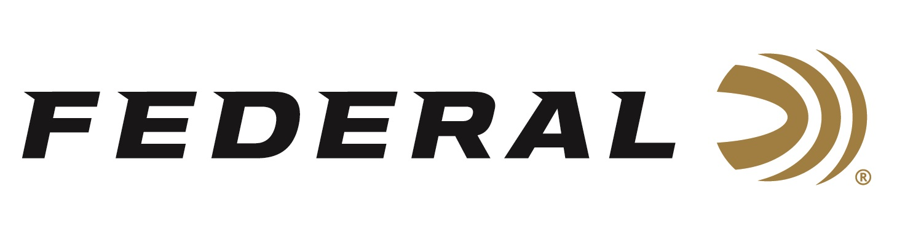

FOR IMMEDIATE RELEASE

Toms Beware: Federal Expands HEAVYWEIGHT TSS Turkey Line

ANOKA, Minnesota – February 11, 2019 – Federal is proud to introduce five new Premium HEAVYWEIGHT TSS turkey shotshell loads, extending the revolutionary shells’ deadly reach on gobblers. Shipments have been delivered to dealers.

The new offerings include blended loads that combine No. 7 and 9 or 8 and 10 Tungsten Super Shot. With some payloads topping 1,000 pellets, they more than double the shot count of lead No. 5 loads of the same weight for more hits on target than any turkey load in history. The tungsten-alloy material’s 18 g/cc density is 22 percent higher than standard tungsten and 56 percent more than lead. The result is the most energy and highest velocities at extreme range. Its rear-braking FLITECONTROL FLEX wad performs flawlessly through ported and standard turkey chokes for the most consistent, deadly patterns possible.

Features & Benefits
- New blended and fine-shot payloads offer unprecedented pellet counts
- HEAVYWEIGHT TSS payload with advanced buffering material
- More than double the pellet count of lead No. 5 loads of the same weight
- 22 percent denser material than standard tungsten; 56 percent denser than lead
- FLITECONTROL FLEX wad provides extremely tight, consistent patterns through standard and ported turkey chokes
- Roll crimp and clear card wad keeps buffering material in place
- Full-length wads prevent direct contact of the extra-hard pellets and the bore, protecting the barrel
- 5-count packs
- A portion of the proceeds are donated to the National Wild Turkey Federation

Part No. / Description / MSRP
PTSSX195F 79 / 12 gauge 3 ½ inch, 2 ½ ounce 7/9, 1000 fps, 5-count / $63.95
PTSSX195F 810 / 12 gauge 3 ½ inch, 2 ½ ounce 8/10, 1000 fps, 5-count / $63.95
PTSSX295F 79 / 20 gauge 3 inch, 1 5/8 ounce 7/9, 1000 fps, 5-count / $46.95
PTSSX295F 810 / 20 gauge 3 inch, 1 5/8 ounce 8/10, 1000 fps, 5-count / $46.95
PTSSX259F 9 / 20 gauge 3 inch, 1 ½ ounce 9, 1100 fps, 5-count / $39.95

For more information on Federal ammunition, visit www.federalpremium.com.

Press Release Contact: JJ Reich
Senior Communications Manager - Ammunition
E-mail: VistaPressroom@VistaOutdoor.com

About Federal Ammunition
Federal, headquartered in Anoka, MN, is a brand of Vista Outdoor Inc., an outdoor sports and recreation company. From humble beginnings nestled among the lakes and woods of Minnesota, Federal Ammunition has evolved into one of the world's largest producers of sporting ammunition. Beginning in 1922, founding president, Charles L. Horn, paved the way for our success. Today, Federal carries on Horn's vision for quality products and service with the next generation of outdoorsmen and women. We maintain our position as experts in the science of ammunition production. Every day we manufacture products to enhance our customers' shooting experience while partnering with the conservation organizations that protect and support our outdoor heritage. We offer thousands of options in our Federal Premium and Federal lines—it’s what makes us the most complete ammunition company in the business and provides our customers with a choice no matter their pursuit.

Federal is part of Vista Outdoor Inc., an outdoor sports and recreation corporation. For news and information on Vista Outdoor Inc., visit www.vistaoutdoor.com.

###

