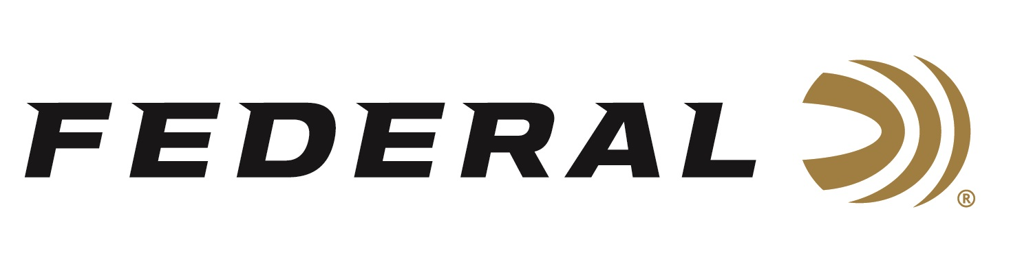

FOR IMMEDIATE RELEASE

Hydra-Shok Bullets Now Available as Components

ANOKA, Minnesota – May 2, 2019 – Federal Premium Hydra-Shok, the bullet design that’s defined self-defense for a generation, is now available as a component for handloaders. Shipments have been delivered to dealers.

Introduced in 1989, Hydra-Shok remains one of the most popular choices for protecting home and family, thanks to a proven hollow point and iconic center post that provide extremely consistent and effective expansion. Now available in a complete range of bullet weights and diameters.

Features & Benefits
- Proven self-defense bullet design now available as a component for reloading
- Superb accuracy and overall ballistic performance
- Notched copper jacket
- Center-post hollow-point design provides reliable expansion

Part No. / Description / MSRP
PB38HS129 / 357 cal. 129-grain, 100-count / $30.95
PB9HS124 / 355 cal. 124-grain, 100-count / $30.95
PB9HS147 / 355 cal. 147-grain, 100-count / $30.95
PB357HS158 / 357 cal. 158-grain, 100-count / $31.95
PB40HS165 / 400 cal. 165-grain, 50-count / $16.95
PB40HS180 / 400 cal. 180-grain, 50-count / $16.95
PB45HS185 / 451 cal. 185-grain, 50-count / $18.95
PB45HS230 / 451 cal. 230-grain, 50-count / $18.95

For more information on Federal ammunition, visit www.federalpremium.com.

Press Release Contact: JJ Reich
Senior Communications Manager - Ammunition
E-mail: VistaPressroom@VistaOutdoor.com

About Federal Ammunition
Federal, headquartered in Anoka, MN, is a brand of Vista Outdoor Inc., an outdoor sports and recreation company. From humble beginnings nestled among the lakes and woods of Minnesota, Federal Ammunition has evolved into one of the world's largest producers of sporting ammunition. Beginning in 1922, founding president, Charles L. Horn, paved the way for our success. Today, Federal carries on Horn's vision for quality products and service with the next generation of outdoorsmen and women. We maintain our position as experts in the science of ammunition production. Every day we manufacture products to enhance our customers' shooting experience while partnering with the conservation organizations that protect and support our outdoor heritage. We offer thousands of options in our Federal Premium and Federal lines—it’s what makes us the most complete ammunition company in the business and provides our customers with a choice no matter their pursuit.

Federal is part of Vista Outdoor Inc., an outdoor sports and recreation corporation. For news and information on Vista Outdoor Inc., visit www.vistaoutdoor.com.

###

