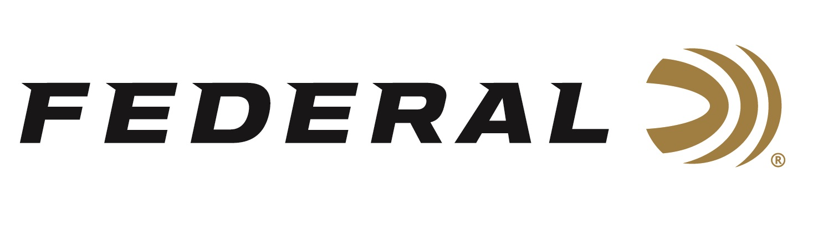

FOR IMMEDIATE RELEASE

Federal Adds 40 S&W, 45 Auto Premium Hydra-Shok Deep Loads

ANOKA, Minnesota – February 14, 2019 – Federal unveils two new Federal Premium Hydra-Shok Deep loads that better meet modern handgun performance measurements. Shipments have been delivered to dealers.

In 2018, Federal reinvented the proven Hydra-Shok bullet design with Hydra-Shok Deep in 9mm Luger. Now, it has expanded the line with new loads in 40 S&W and 45 Auto. The bullets feature a more robust center post and a core design that penetrates to critical depths through common self-defense barriers, without over-penetrating.

Features & Benefits
- Now available in 40 S&W and 45 Auto
- Penetrates 15 inches in bare ballistics gel and through heavy clothing — the optimal depth according to FBI standards
- Improved penetration to optimal depths
- Significant improvement in FBI protocol score
- Iconic center post design has been improved for better, more consistent expansion through standard barriers
- Consistent, specially formulated propellant
- Extremely reliable Federal primer

Part No. / Description / MSRP
P9HSD1 / 9mm Luger 135-grain Hydra-Shok Deep HP / $27.95
P40HSD1 / 40 S&W 165-grain Hydra-Shok Deep HP / $31.95 NEW
P45HSD1 / 45 Auto 210-grain Hydra-Shok Deep HP / $33.95 NEW

For more information on Federal ammunition, visit www.federalpremium.com.

Press Release Contact: JJ Reich
Senior Communications Manager - Ammunition
E-mail: VistaPressroom@VistaOutdoor.com

About Federal Ammunition
Federal, headquartered in Anoka, MN, is a brand of Vista Outdoor Inc., an outdoor sports and recreation company. From humble beginnings nestled among the lakes and woods of Minnesota, Federal Ammunition has evolved into one of the world's largest producers of sporting ammunition. Beginning in 1922, founding president, Charles L. Horn, paved the way for our success. Today, Federal carries on Horn's vision for quality products and service with the next generation of outdoorsmen and women. We maintain our position as experts in the science of ammunition production. Every day we manufacture products to enhance our customers' shooting experience while partnering with the conservation organizations that protect and support our outdoor heritage. We offer thousands of options in our Federal Premium and Federal lines—it’s what makes us the most complete ammunition company in the business and provides our customers with a choice no matter their pursuit.

Federal is part of Vista Outdoor Inc., an outdoor sports and recreation corporation. For news and information on Vista Outdoor Inc., visit www.vistaoutdoor.com.

###

