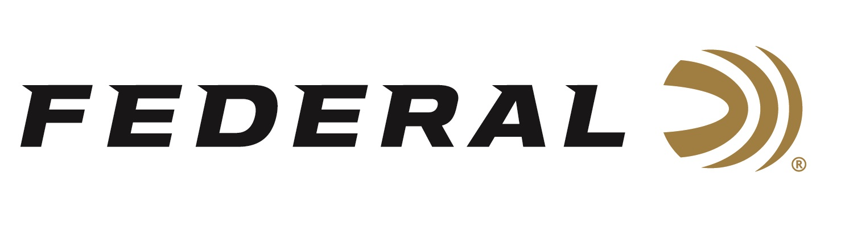

FOR IMMEDIATE RELEASE

Federal Adds 6.5 Creedmoor, 6.5 Grendel to
Premium Unprimed Brass Lineup

ANOKA, Minnesota – April 10, 2019 – Federal has expanded its line of Premium unprimed brass to include 6.5 Creedmoor and 6.5 Grendel cases. Shipments have been delivered to dealers.

Federal been producing the industry’s finest brass since the early 1950s, when the first centerfire rounds rolled off its machines. The tradition continues today with the additional options for 6.5 Creedmoor and 6.5 Grendel, two of the hottest cartridges in shooting.

Features & Benefits
- New 6.5 Grendel and 6.5 Creedmoor unprimed cases
- Industry’s best brass
- Precise dimensional tolerances ensure peak accuracy
- Consistent volumes and performance
- Case shoulders and necks are annealed for long life and easier resizing

Part No. / Description / MSRP
PR65GDLUPB50 / 6.5 Grendel, 50-count / $24.95
PR65CRDUPB50 / 6.5 Creedmoor, 50-count / $23.95

For more information on Federal ammunition, visit www.federalpremium.com.

Press Release Contact: JJ Reich
Senior Communications Manager - Ammunition
E-mail: VistaPressroom@VistaOutdoor.com

About Federal Ammunition
Federal, headquartered in Anoka, MN, is a brand of Vista Outdoor Inc., an outdoor sports and recreation company. From humble beginnings nestled among the lakes and woods of Minnesota, Federal Ammunition has evolved into one of the world's largest producers of sporting ammunition. Beginning in 1922, founding president, Charles L. Horn, paved the way for our success. Today, Federal carries on Horn's vision for quality products and service with the next generation of outdoorsmen and women. We maintain our position as experts in the science of ammunition production. Every day we manufacture products to enhance our customers' shooting experience while partnering with the conservation organizations that protect and support our outdoor heritage. We offer thousands of options in our Federal Premium and Federal lines—it’s what makes us the most complete ammunition company in the business and provides our customers with a choice no matter their pursuit.

Federal is part of Vista Outdoor Inc., an outdoor sports and recreation corporation. For news and information on Vista Outdoor Inc., visit www.vistaoutdoor.com.

###

