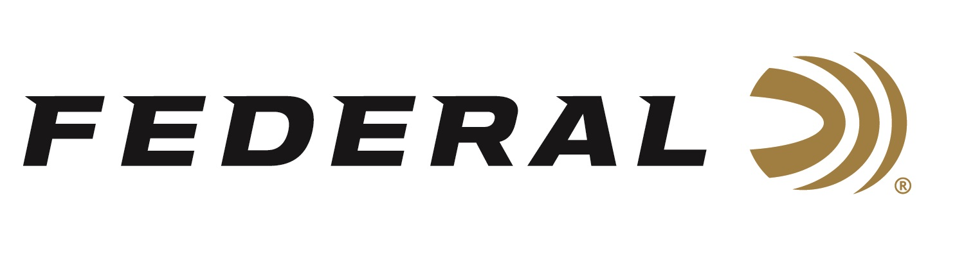

FOR IMMEDIATE RELEASE

New Syntech Defense Loads Produce Top Terminal Performance

ANOKA, Minnesota – April 11, 2019 – From the No. 1 Brand in Handgun Ammunition, Federal is proud to introduce new Syntech Defense. These loads produce dynamic terminal performance with a hollow-point bullet that separates into three segments and a deep-penetrating core on impact. Shipments of Syntech Defense ammunition have been delivered to dealers.

The original Syntech changed the range forever. Now, the technology is also revolutionizing protection. The bullet in Syntech Defense has a core that penetrates 12 to 18 inches through bare ballistics gel and heavy clothing — a critical benchmark in self-defense situations and the best terminal performance of any round in its class. The segments create three secondary wound channels, each more than 6 inches deep, adding to the terminal effect.

Like all Syntech loads, an advanced polymer jacket eliminates lead and copper fouling and drastically reduces damaging heat and friction in the barrel. Its Federal exclusive Catalyst primer provides hot, extremely reliable ignition without the use of lead.

Features & Benefits
• Best terminal performance in its class
• Hollow-point bullet separates into three segments and a deep-penetrating core on impact
• Core achieves 12 to 18 inches of penetration in both bare ballistics gel and through heavy clothing
• Segments create three secondary wound channels more than 6 inches deep
• Blue polymer jacket reduces barrel heat and friction and eliminates metal fouling
• Extremely reliable Catalyst lead-free primer

Part No. / Description / MSRP
S9SJT1 / Syntech Defense 9mm Luger 138 grain, 20-count / $19.95
S40SJT1 / Syntech Defense 40 S&W, 175 grain, 20-count / $22.95
S45SJT1 / Syntech Defense 45 Auto, 205 grain, 20-count / $24.95

For more information on Federal ammunition, visit www.federalpremium.com.

Press Release Contact: JJ Reich
Senior Communications Manager - Ammunition
E-mail: VistaPressroom@VistaOutdoor.com

About Federal Ammunition
Federal, headquartered in Anoka, MN, is a brand of Vista Outdoor Inc., an outdoor sports and recreation company. From humble beginnings nestled among the lakes and woods of Minnesota, Federal Ammunition has evolved into one of the world's largest producers of sporting ammunition. Beginning in 1922, founding president, Charles L. Horn, paved the way for our success. Today, Federal carries on Horn's vision for quality products and service with the next generation of outdoorsmen and women. We maintain our position as experts in the science of ammunition production. Every day we manufacture products to enhance our customers' shooting experience while partnering with the conservation organizations that protect and support our outdoor heritage. We offer thousands of options in our Federal Premium and Federal lines—it’s what makes us the most complete ammunition company in the business and provides our customers with a choice no matter their pursuit.

Federal is part of Vista Outdoor Inc., an outdoor sports and recreation corporation. For news and information on Vista Outdoor Inc., visit www.vistaoutdoor.com.

###

