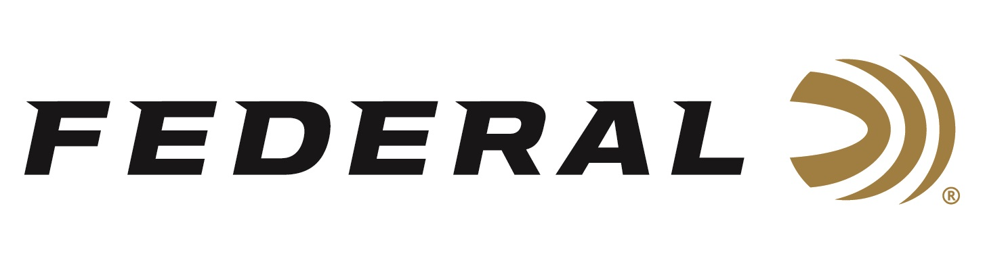

FOR IMMEDIATE RELEASE

Federal Introduces Syntech PCC for the Heavy Demands of Pistol Caliber Carbine Competition Shooters

ANOKA, Minnesota – August 21, 2019 – Federal is excited to announce its new Syntech PCC 9mm Luger load, designed to meet the exhaustive demands of fast-paced Pistol Caliber Carbine competitions, with flawless function in carbine platforms. Shipments of Syntech PCC ammunition have been delivered to dealers.

The load’s velocity and accuracy are optimized for long gun-barrel lengths, with a bullet profile that provides excellent accuracy and reliable feeding in a variety of carbine platforms. Syntech PCC joins the Syntech Action Pistol offering as official ammunition of United States Practical Shooting Association (USPSA).

Like all Syntech loads, Syntech PCC features the one-of-a-kind TSJ projectile, which uses a polymer jacket to eliminate metal fouling and drastically reduce damaging barrel heat and friction. The bullet style also minimizes splash-back on steel targets. Its exclusive Catalyst primer provides hot, reliable ignition without the use of lead.

“Syntech PCC is offered in 9mm Luger 130-grain is all about having a better shooting experience when shooting a pistol cartridge, historically speaking, through a rilfe platform,” said Federal Centerfire Product Director Mike Holm. “With Syntech, you naturally have it—more features of what all shooters want, and less of what you don’t.”

Features
- 9mm Luger load specifically designed for use in carbines
- Velocities optimized for longer barrels
- Bullet profile designed for reliable feeding in carbine platforms
- Catalyst high-performance lead-free primer
- Total Synthetic Jacket prevents metal fouling
- Drastically reduces barrel heat and friction
- Minimizes splash-back on hard targets

Part No. / Description / MSRP
AE9SJPC1 / 9mm Luger 130-grain Syntech PCC, 50-count, 1130 fps / $19.95

For more information on Federal ammunition, visit www.federalpremium.com.

Press Release Contact: JJ Reich
Senior Communications Manager - Ammunition
E-mail: VistaPressroom@VistaOutdoor.com

About Federal Ammunition
Federal, headquartered in Anoka, MN, is a brand of Vista Outdoor Inc., an outdoor sports and recreation company. From humble beginnings nestled among the lakes and woods of Minnesota, Federal Ammunition has evolved into one of the world's largest producers of sporting ammunition. Beginning in 1922, founding president, Charles L. Horn, paved the way for our success. Today, Federal carries on Horn's vision for quality products and service with the next generation of outdoorsmen and women. We maintain our position as experts in the science of ammunition production. Every day we manufacture products to enhance our customers' shooting experience while partnering with the conservation organizations that protect and support our outdoor heritage. We offer thousands of options in our Federal Premium and Federal lines—it’s what makes us the most complete ammunition company in the business and provides our customers with a choice no matter their pursuit.

###

