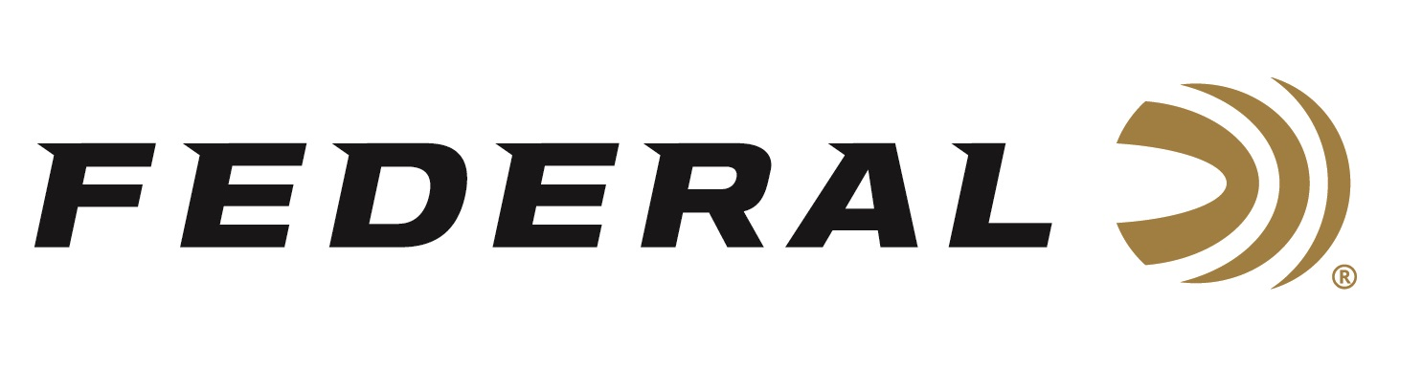

FOR IMMEDIATE RELEASE

Federal Makes Practice Powerful with Syntech Training Match

ANOKA, Minnesota – March 6, 2019 – Federal proudly introduces Syntech Training Match, loads designed to make your handgun training more realistic than ever before. Shipments have been delivered to dealers.

Syntech Training Match loads offer the same velocity, trajectory and point of impact as equivalent Federal Premium Personal Defense HST and Tactical HST duty ammunition. Like all Syntech offerings, Syntech Training Match features the one-of-a-kind TSJ projectile, which uses a polymer jacket to eliminate metal fouling and drastically reduce damaging barrel heat and friction. Its Federal-exclusive Catalyst primer provides hot, reliable ignition without lead, making Syntech Training Match perfect for indoor ranges.

Features & Benefits
- Identical point of impact, velocity and trajectory as equivalent HST loads
- Extremely realistic and effective practice
- Purple jacket visually identifies matched training round
- Catalyst high-performance lead-free primer
- Total Synthetic Jacket prevents metal fouling
- Drastically reduces barrel heat and friction
- Minimizes splash-back on hard targets

Part No. / Description / MSRP
AE9SJ3 / Syntech Training Match 9mm Luger 147 grain TSJ, 50-count, 1150 fps / $19.95
AE9SJ4 / Syntech Training Match 9mm Luger 124 grain TSJ, 50-count, 1150 fps / $19.95
AE40SJ2 / Syntech Training Match 40 S&W 180 grain TSJ, 50-count, 1010 fps / $25.95
AE45SJ2 / Syntech Training Match 45 Auto 230 grain TSJ, 50-count, 890 fps / $31.95

For more information on Federal ammunition, visit www.federalpremium.com.

Press Release Contact: JJ Reich
Senior Communications Manager - Ammunition
E-mail: VistaPressroom@VistaOutdoor.com

About Federal Ammunition
Federal, headquartered in Anoka, MN, is a brand of Vista Outdoor Inc., an outdoor sports and recreation company. From humble beginnings nestled among the lakes and woods of Minnesota, Federal Ammunition has evolved into one of the world's largest producers of sporting ammunition. Beginning in 1922, founding president, Charles L. Horn, paved the way for our success. Today, Federal carries on Horn's vision for quality products and service with the next generation of outdoorsmen and women. We maintain our position as experts in the science of ammunition production. Every day we manufacture products to enhance our customers' shooting experience while partnering with the conservation organizations that protect and support our outdoor heritage. We offer thousands of options in our Federal Premium and Federal lines—it’s what makes us the most complete ammunition company in the business and provides our customers with a choice no matter their pursuit.

Federal is part of Vista Outdoor Inc., an outdoor sports and recreation corporation. For news and information on Vista Outdoor Inc., visit www.vistaoutdoor.com.

###

