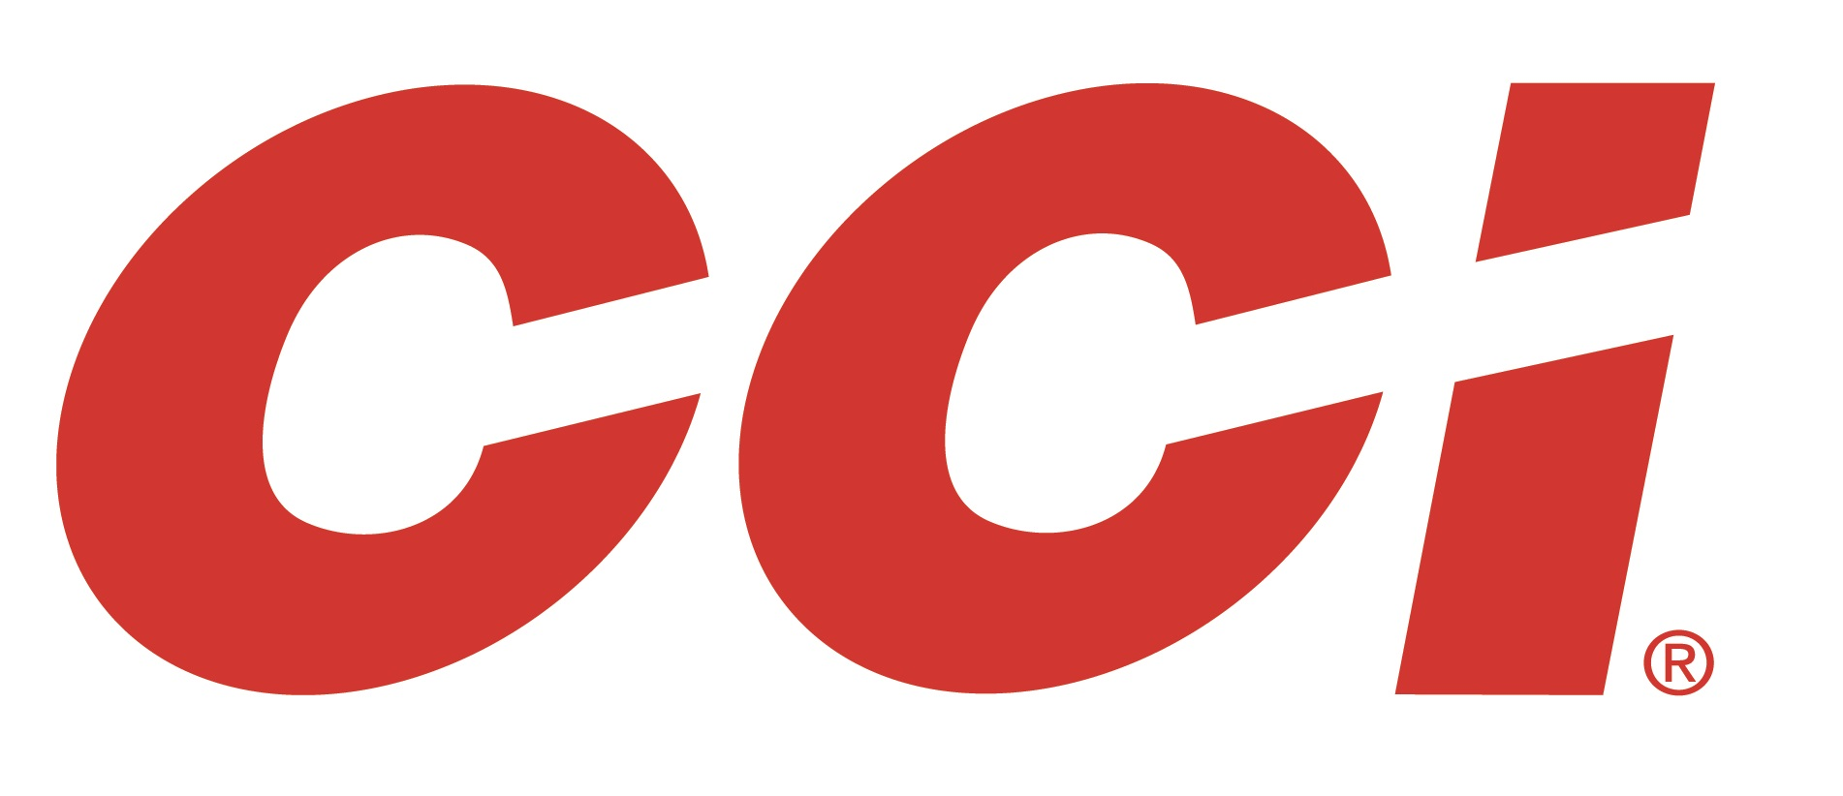
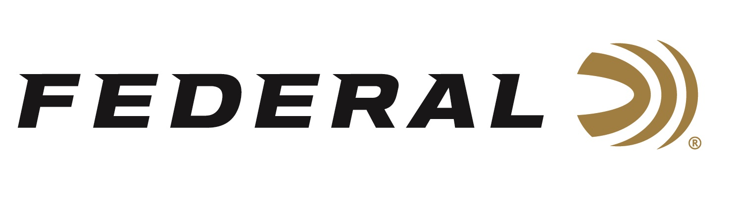

FOR IMMEDIATE RELEASE

CCI & Federal Ammunition Sponsored Shooter Shines at Steel Challenges

ANOKA, Minnesota – October 4, 2019 – September was a month to remember for CCI & Federal Ammunition sponsored shooter Grant Kunkel. From Pennsylvania to Mississippi, Kunkel has been ringing steel and placing in top podium positions.

Kunkel, an 18 year old from Story, Arkansas, began the month at the East Coast Steel Championships held at the Ontelaunee Rod & Gun Club near New Tripoli, PA. Competing in eight events with five-hundred competitors, Kunkel finished runner-up in six of those competitions and claimed a first place in the Rimfire Rifle Optic match shooting CCI’s Clean-22 High Velocity 22LR. “My CCI Clean HV ammunition from CCI kept my guns clean and running great,” said Kunkel.

Kunkel kept his winning ways going at the Mississippi State Steel Challenge held at the Brothers N Arms Range in Hattiesburg, MS last weekend. Competing in five events and against nearly 300 competitors, Kunkel finished first in Rimfire Rifle Optic, Rimfire Rifle Iron, Rimfire Pistol Optic, PCC Iron, and Carry Optics and finished High Overall. “I was pleased to have earned a high overall win at the 2019 Mississippi State Steel Championship,” continued Kunkel.

Kunkel relied on CCI’s Clean-22 High Velocity 22LR ammunition for the rimfire competitions and Federal’s Syntech Action Pistol ammunition in the handgun matches. “It’s great to know that I can always count on my ammo to perform when it matters,” he said.

For more information on CCI Ammunition, go to www.cci-ammunition.com. For more information on Federal ammunition, visit www.federalpremium.com.

Press Release Contact: JJ Reich
Senior Communications Manager - Firearms and Ammunition
E-mail: VistaPressroom@VistaOutdoor.com

About CCI Ammunition
Dick Speer founded Cascade Cartridge, Inc. in 1951 next to the Snake River in Lewiston, Idaho. The company manufactured and marketed centerfire primers for government use in its infancy. CCI now develops them for sporting applications as part of Vista Outdoor and is the world leader in rimfire products. The company also produces industrial powerloads and Blazer centerfire handgun ammunition. For more information, visit www.cci-ammunition.com

About Federal Ammunition
Federal, headquartered in Anoka, MN, is a brand of Vista Outdoor Inc., an outdoor sports and recreation company. From humble beginnings nestled among the lakes and woods of Minnesota, Federal Ammunition has evolved into one of the world's largest producers of sporting ammunition. Beginning in 1922, founding president, Charles L. Horn, paved the way for our success. Today, Federal carries on Horn's vision for quality products and service with the next generation of outdoorsmen and women. We maintain our position as experts in the science of ammunition production. Every day we manufacture products to enhance our customers' shooting experience while partnering with the conservation organizations that protect and support our outdoor heritage. We offer thousands of options in our Federal Premium and Federal® lines-it's what makes us the most complete ammunition company in the business and provides our customers with a choice no matter their pursuit.

###

