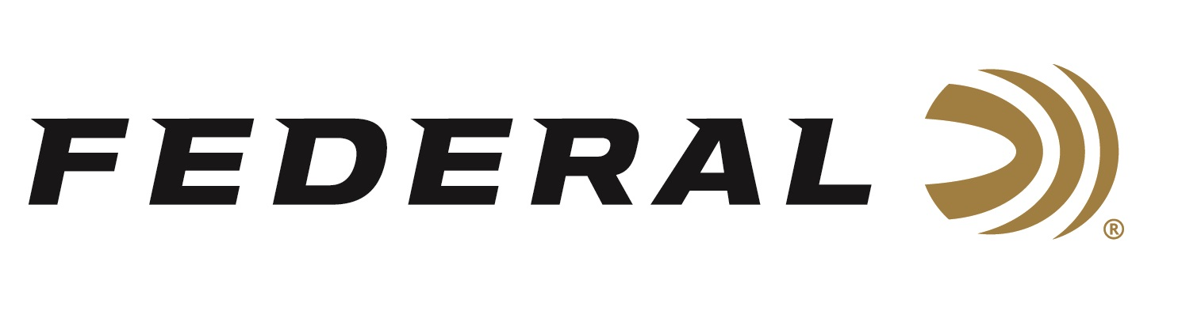

FOR IMMEDIATE RELEASE

Buckets of Federal’s Award-Winning Syntech Range Ammunition
Now Available

ANOKA, Minnesota – November 6, 2019 – From the largest ammunition manufacturer of the world comes all-new Syntech Bulk Buckets boast 250 to 500 rounds packed in rugged plastic buckets that stack, store and transport easily. Shipments of this product have been delivered to dealers.

“Conventional ammunition causes metal-on-metal contact between the bullet and bore, which can shorten barrel life and rob accuracy. The polymer-encapsulated Syntech bullet prevents this, while eliminating copper and lead fouling,” explained Federal Handgun Ammunition Product Manager Chris Laack. “Combined with specialized clean-burning powders, your gun will stay cleaner, longer, so you can shoot more and shoot better. The exclusive Catalyst primer provides the cleanest most consistent ignition possible. That’s why it received the 2017 NRA Golden Bullseye Award. And now, we sell it by the bucket full.”

The one-of-a-kind TSJ projectile uses a polymer jacket to eliminate metal fouling and drastically reduce damaging barrel heat and friction. The bullet style also minimizes splash-back on steel targets. Its exclusive Catalyst primer provides hot, reliable ignition without the use of lead. There’s never been a better way to have an epic day at the range.

Features
- 250- to 500-round loose bulk packs
- Rugged plastic buckets stack, store and transport easily
- Catalyst high-performance lead-free primer
- Total Synthetic Jacket prevents metal fouling
- Drastically reduces barrel heat and friction
- Minimizes splash-back on hard targets

Part No. / Description / MSRP
AE9SJ2B500 / 9mm Luger 124-grain Syntech TSJ 500-count bucket / $193.95
AE9SJ2B250 / 9mm Luger 124-grain Syntech TSJ 250-count bucket / $96.95
AE40SJ1B350 / 40 S&W 165-grain Syntech TSJ 350-count bucket / $174.95
AE45SJ1B300 / 45 Auto 230-grain Syntech TSJ 300-count bucket / $187.95

Learn more at Federal and all its ammunition products visit: www.federalpremium.com.

Press Release Contact: JJ Reich
Senior Communications Manager
E-mail: VistaPressroom@VistaOutdoor.com

About Federal Ammunition
Federal, headquartered in Anoka, MN, is a brand of Vista Outdoor Inc., an outdoor sports and recreation company. From humble beginnings nestled among the lakes and woods of Minnesota, Federal Ammunition has evolved into one of the world's largest producers of sporting ammunition. Beginning in 1922, founding president, Charles L. Horn, paved the way for our success. Today, Federal carries on Horn's vision for quality products and service with the next generation of outdoorsmen and women. We maintain our position as experts in the science of ammunition production. Every day we manufacture products to enhance our customers' shooting experience while partnering with the conservation organizations that protect and support our outdoor heritage. We offer thousands of options in our Federal Premium and Federal® lines-it's what makes us the most complete ammunition company in the business and provides our customers with a choice no matter their pursuit.

