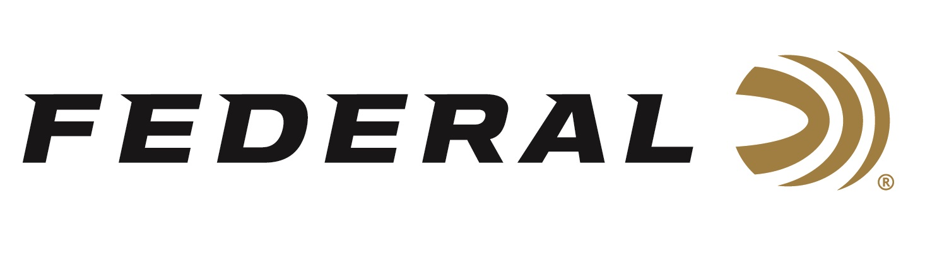

FOR IMMEDIATE RELEASE

U.S. Department of Homeland Security (DHS) Awards Federal Ammunition a Tactical Buckshot Duty Ammunition Contract

ANOKA, Minnesota – October 28, 2019 – The U.S. Immigration and Customs Enforcement (ICE) recently awarded Federal Premium a major ammunition contract. Starting delivery in 2019, the contract provides for up to 2,227,500 shells of 12-gauge 2-3/4 Inch, 00 Buckshot (Reduced Recoil) duty ammunition to multiple Department of Homeland Security law enforcement components and other federal agencies for up to five (5) years. This contract will provide the organization’s agents and officers with 12-gauge Tactical Buckshot duty ammunition.

“We are proud to provide the highest quality duty ammunition to DHS agents in the field,” said Federal Ammunition President Jason Vanderbrink. “Officers in the field require the highest quality ammunition at their disposal, in their vigilant fight to protect our freedoms. Federal Tactical ammunition ensures the highest performance threshold, and absolute officer confidence in terminal performance.”

Federal Tactical is a trusted partner for some of the most intense conditions encountered by law enforcement. The ammunition utilizes the highest quality Federal brass, projectiles and primers. The ammunition awarded in this contract is similar to Federal’s LE133 00 load. This Federal Law Enforcement shotgun ammo features a FLITECONTROL wad. Tactical Buckshot also features copper-plated shot and recoil reduction that, when combined with the FLITECONTROL wad, result in the most dependable and predictable pattern performance available.

ICE, which was created in 2003, is tasked with promoting homeland security and safety, as well as enforcing federal laws governing border control, immigration, customs and trade. The agency has more than 20,000 employees in more than 400 stateside offices and 46 foreign countries. ICE executes its mission through the enforcement of more than 400 federal statutes, and focuses on immigration enforcement, terrorism prevention and combating the illegal movement of people and trade.

Federal is one of the world’s leading manufacturers in Tactical and Law Enforcement shotgun, rifle and handgun training ammunition. For more information on Federal ammunition, visit www.federalpremium.com.

Press Release Contact: JJ Reich
Senior Communications Manager
E-mail: VistaPressroom@VistaOutdoor.com

About Federal Ammunition
Federal, headquartered in Anoka, MN, is a brand of Vista Outdoor Inc., an outdoor sports and recreation company. From humble beginnings nestled among the lakes and woods of Minnesota, Federal Ammunition has evolved into one of the world's largest producers of sporting ammunition. Beginning in 1922, founding president, Charles L. Horn, paved the way for our success. Today, Federal carries on Horn's vision for quality products and service with the next generation of outdoorsmen and women. We maintain our position as experts in the science of ammunition production. Every day we manufacture products to enhance our customers' shooting experience while partnering with the conservation organizations that protect and support our outdoor heritage. We offer thousands of options in our Federal Premium and Federal lines—it’s what makes us the most complete ammunition company in the business and provides our customers with a choice no matter their pursuit.

###

