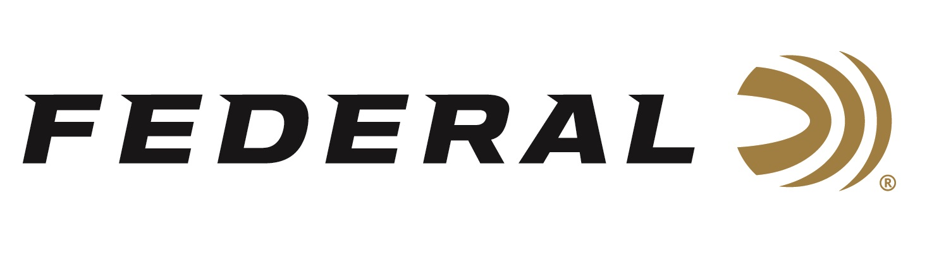

FOR IMMEDIATE RELEASE

Federal Awarded $12.9 million MK311 Mod 3 Delivery Order

ANOKA, Minnesota – September 24, 2019 - Federal Ammunition was awarded a new delivery order worth $12.9 million under its MK311 Mod 3 Frangible Ammunition contract. Orders were placed under the company's small-caliber ammunition contract, issued by the U.S. Army Contracting Command in 2017.

5.56mm MK311 Frangible Ammunition, better known by its ordnance code, “AA40”, is loaded with a 50-grain frangible bullet comprised of a non-toxic, copper and tungsten powder matrix in a gilding metal jacket. The frangible ammunition is designed to disintegrate into small fragments on impact, minimizing over-penetration and ricochet hazards. The polymer compound round produces limited splash back, which vastly decreases ricochets, making it ideal for training applications.

“This latest order continues our long history of supplying only the highest quality, most reliable ammunition,” said Federal Ammunition President Jason Vanderbrink, “at Federal we use innovative technology, with industry-leading components to produce specialized products for training and the battlefield. The ammunition we produce serves the U.S. military, and we are humbled to do so.”

Federal is one of the world’s leading manufacturers in 5.56mm tactical and training ammunition. For more information on Federal ammunition, visit www.federalpremium.com.

Press Release Contact: JJ Reich
Senior Communications Manager - Ammunition
E-mail: VistaPressroom@VistaOutdoor.com

About Federal Ammunition
Federal, headquartered in Anoka, MN, is a brand of Vista Outdoor Inc., an outdoor sports and recreation company. From humble beginnings nestled among the lakes and woods of Minnesota, Federal Ammunition has evolved into one of the world's largest producers of sporting ammunition. Beginning in 1922, founding president, Charles L. Horn, paved the way for our success. Today, Federal carries on Horn's vision for quality products and service with the next generation of outdoorsmen and women. We maintain our position as experts in the science of ammunition production. Every day we manufacture products to enhance our customers' shooting experience while partnering with the conservation organizations that protect and support our outdoor heritage. We offer thousands of options in our Federal Premium and Federal lines—it’s what makes us the most complete ammunition company in the business and provides our customers with a choice no matter their pursuit.

###

