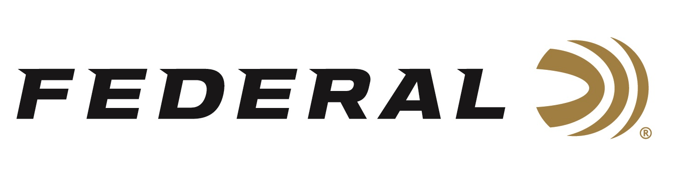

FOR IMMEDIATE RELEASE

Federal BYOB Buckets and Bottles Make a Party Out of
Rimfire Range Time

ANOKA, Minnesota – July 19, 2019 – Federal is excited to launch BYOB rimfire buckets and bottles, which are perfect for a fun day at the range or in the field. Shipments have been delivered to dealers.

BYOB rimfire buckets and bottles are bulk packs that stack, store and carry easily. They’re loaded with high-quality 17 HMR, 22 LR or 22 WMR rounds. Shooters can remove the packs’ lids completely or keep them on to use the easy-pour feature.

Features & Benefits
- Quality 17 HMR, 22 LR and 22 WMR loads for the range or hunting
- Plastic bulk packs stack and store easily
- Removable lids allow easy access and pouring
- Accurate, consistent performance at a value price

Part No. / Description / MSRP
770BTL250 / BYOB Bottle 17 HMR 17 grain JHP 2530 fps 250-count / $63.95
750BTL450 / BYOB Bottle 22 LR 36 grain CPHP 1260 fps 450-count / $30.95
750BKT825 / BYOB Bucket 22 LR 36 grain CPHP 1260 fps 825-count / $51.95
750BKT1375 / BYOB Bucket 22 LR 36 grain CPHP 1260 fps 1375-count / $86.95
757BTL250 / BYOB Bottle 22 WMR 50 grain JHP 1530 fps 250-count / $67.95

For more information on Federal ammunition, visit www.federalpremium.com.

Press Release Contact: JJ Reich
Senior Communications Manager - Ammunition
E-mail: VistaPressroom@VistaOutdoor.com

About Federal Ammunition
Federal, headquartered in Anoka, MN, is a brand of Vista Outdoor Inc., an outdoor sports and recreation company. From humble beginnings nestled among the lakes and woods of Minnesota, Federal Ammunition has evolved into one of the world's largest producers of sporting ammunition. Beginning in 1922, founding president, Charles L. Horn, paved the way for our success. Today, Federal carries on Horn's vision for quality products and service with the next generation of outdoorsmen and women. We maintain our position as experts in the science of ammunition production. Every day we manufacture products to enhance our customers' shooting experience while partnering with the conservation organizations that protect and support our outdoor heritage. We offer thousands of options in our Federal Premium and Federal lines—it’s what makes us the most complete ammunition company in the business and provides our customers with a choice no matter their pursuit.

###

