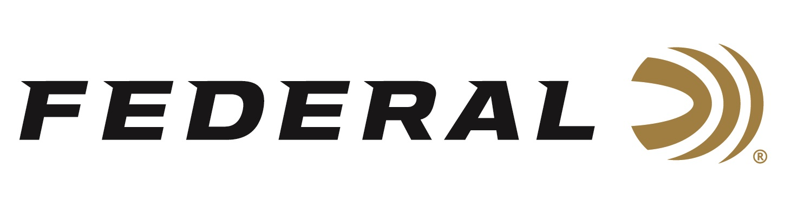

FOR IMMEDIATE RELEASE

Field & Stream Magazine Honors Federal Premium Black Cloud TSS as Best of the Best for 2019

ANOKA, Minnesota – November 12, 2019 – Field & Stream magazine recently recognized Federal Premium Black Cloud TSS with an Editors’ choice honor for best-of-the-best in ammunition, as part of the magazine’s Field Test Buyer’s Guide in the December 2019 – January, 2020 issue. Federal’s latest new product for its Black Cloud with FLITECONTROL FLEX lineup features rounds loaded with Tungsten Super Shot (TSS) which helped the new waterfowl ammunition earn the honor.

“Our new Black Cloud TSS carries on a lethal legacy, blending proven FLITESTOPPER Steel pellets and 18 g/cc TSS. Its performance is just simply devastating on any waterfowl,” said Federal Shotshell Product Manager Dan Compton. “We were extremely happy to see that it exceeded all of Field & Stream Editor Will Brantley’s high expectations.”

The new Black Cloud TSS recipe blends 60 percent HEAVYWEIGHT TSS pellets, instead of the straight steel, and 40 percent FLITESTOPPER steel. These high-end loads feature No. 7 or No. 9 TSS mixed with BB or No. 3 FLITESTOPPER steel. The loads also feature Federal’s lead-free Catalyst primers and clean, fast-burning propellant. The FLITECONTROL FLEX wad provides the most consistent patterns in all types and port-styles of chokes. The new Black Cloud TSS extends effective range past 50 yards.

“With No. 9 Tungsten Super Shot blended with FLITESTOPPER steel, Black Cloud TSS delivers forgiving patterns and long-range thump unlike any duck load I’ve ever tried,” stated Brantley in the article.

Field & Stream is “The World’s Leading Outdoor Magazine.” Devoted to the complete outdoor experience and lifestyle, Field & Stream gives its readers the knowledge and inspiration to pursue the sports they love. The brand celebrates the outdoor experience with great stories, compelling photography and sound advice, while honoring the traditions hunters and fishermen have passed down for generations.

Learn more at Federal and all its ammunition products visit: www.federalpremium.com.

Press Release Contact: JJ Reich
Senior Manager – Press Relations
E-mail: VistaPressroom@VistaOutdoor.com

About Federal Ammunition
Federal, headquartered in Anoka, MN, is a brand of Vista Outdoor Inc., an outdoor sports and recreation company. From humble beginnings nestled among the lakes and woods of Minnesota, Federal Ammunition has evolved into one of the world's largest producers of sporting ammunition. Beginning in 1922, founding president, Charles L. Horn, paved the way for our success. Today, Federal carries on Horn's vision for quality products and service with the next generation of outdoorsmen and women. We maintain our position as experts in the science of ammunition production. Every day we manufacture products to enhance our customers' shooting experience while partnering with the conservation organizations that protect and support our outdoor heritage. We offer thousands of options in our Federal Premium and Federal® lines-it's what makes us the most complete ammunition company in the business and provides our customers with a choice no matter their pursuit.

