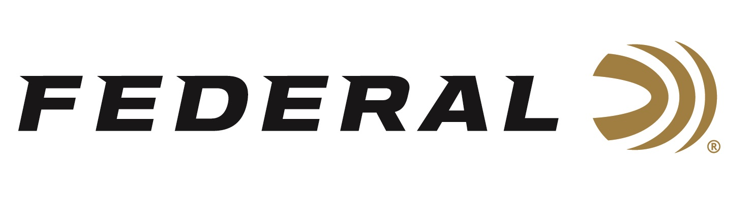

FOR IMMEDIATE RELEASE

Win Federal Train + Protect Personal Defense Ammunition
ANOKA, Minnesota – October 3, 2019 – When it comes to your personal defense strategy, it’s a good idea to make sure you have an entire toolbox on hand, a Tactical Toolbox, if you will. Federal Ammunition has partnered with Brand Avalanche on a one of a kind sweepstakes: The Tactical Toolbox Giveaway!
By entering at tacticaltoolboxgiveaway.com, one lucky entry will win everything you need to learn, train, and defend your home. From firearms to gun accessories to cleaning kits and a security camera, this contest will fill your tactical toolbox and more including Federal American Eagle MSR 5.56 and Federal Train + Protect ammunition.
Federal Train + Protect uses the VHP bullet design to provide precision and practical performance at the range with instant reliable expansion on impact. The result is the ideal combination for training as well as defense.
The contest runs through midnight on October 31 with a total prize package valued at about $6,000. To check out all the products available in this sweepstakes, go to www.tacticaltoolboxgiveaway.com and enter today.
For more information on Federal ammunition, visit www.federalpremium.com.

Press Release Contact: JJ Reich
Senior Communications Manager - Firearms and Ammunition
E-mail: VistaPressroom@VistaOutdoor.com

About Federal Ammunition
Federal, headquartered in Anoka, MN, is a brand of Vista Outdoor Inc., an outdoor sports and recreation company. From humble beginnings nestled among the lakes and woods of Minnesota, Federal Ammunition has evolved into one of the world's largest producers of sporting ammunition. Beginning in 1922, founding president, Charles L. Horn, paved the way for our success. Today, Federal carries on Horn's vision for quality products and service with the next generation of outdoorsmen and women. We maintain our position as experts in the science of ammunition production. Every day we manufacture products to enhance our customers' shooting experience while partnering with the conservation organizations that protect and support our outdoor heritage. We offer thousands of options in our Federal Premium and Federal® lines-it's what makes us the most complete ammunition company in the business and provides our customers with a choice no matter their pursuit.

###

