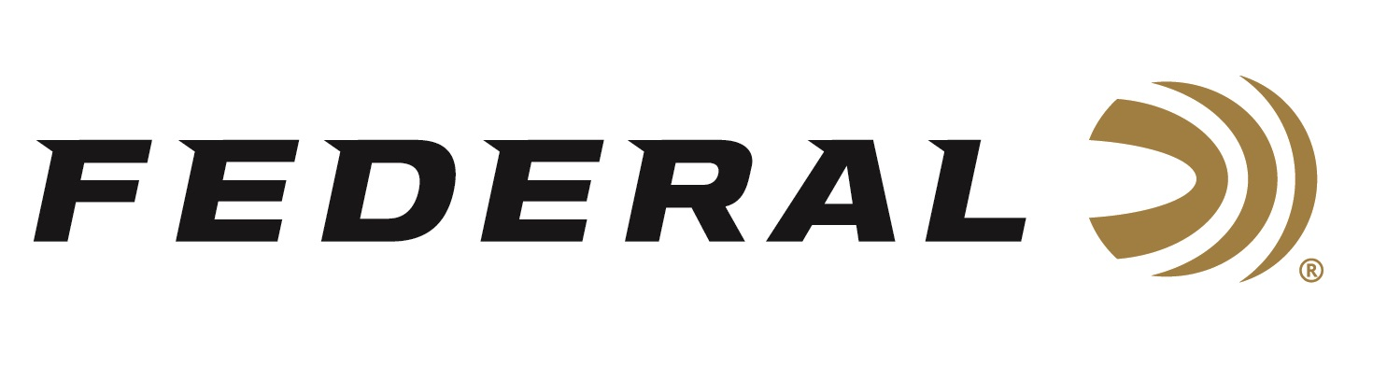

FOR IMMEDIATE RELEASE

Competition Shooter and Federal Ammunition Employee Casey Reed Finishes Strong at the USPSA National Championship

ANOKA, Minnesota – November 25, 2019 – Federal Ammunition employee, competition shooter and brand ambassador Casey Reed finished strong with second place honors in the Limited 10 Division at the recent 2019 United States Practical Shooting Association (USPSA) Lo-Cap National Championship. The competition was held at the Universal Shooting Academy in Frostproof, Florida on November 3 to 5, 2019. Reed is an employee of Federal Ammunition who works as a Handgun Product Development Engineer.

“Last season, Reed was crowned as the 2018 National Champion with a first-place finish. This year, we congratulate Reed on his hard-earned, strong finish at this incredibly competitive event. The honor speaks volumes for his skills and the products he competes with, as well as works hard on every day on to help manufacture,” said Federal Senior Marketing Director Jason Nash. “Our dedicated employees not only design, develop, test, manufacture and deliver the best ammunition on the market, many of us also count on it to help us succeed in our shooting competition goals and hunting enjoyment. It’s a lifestyle we are all certainly proud of.”

Reed used Syntech Action Pistol 40 S&W, 205-grain ammunition at this event. Federal also offers Syntech Action Pistol in 9mm Luger, 150-grain and 45 Auto, 220-grain. Designers configured the loads to meet the accuracy, reliability and power factor requirements of shooters who compete in the International Practice Shooting Confederation (IPSC) and United States Practical Shooting Association (USPSA).

“The Universal Shooting Academy always draws the best shooters from around the nation, as well as put on the most thought-out, well-rounded matches,” said Reed. “I am happy and grateful to have had the opportunity to compete at this incredible event and be able to take second place using our Syntech Action Pistol Ammo.”

Syntech ammunition replaces standard copper jacketing with an exclusive polymer-encapsulated bullet. Its Total Synthetic Jacket (TSJ) prevents metal-on-metal contact between bullet and barrel, eliminating copper and lead fouling while reducing damaging heat and friction, thereby reducing cleaning chores and extending barrel life. Its heavy, flatter-nose bullets provide more reliable knock-downs on steel targets in competition and drastically reduce splash-back. The flat-nose bullet design also helps competitors produce better holes when shooting paper targets. In addition, Syntech Action Pistol uses clean-burning powders that minimize barrel residue, and its Catalyst lead-free primer provides consistent, reliable ignition.
Federal Ammunition is a sponsor of the USPSA, and Syntech Action Pistol is the official sponsored ammo of the organization, with their logo on the box. Learn more about the USPSA at www.uspsa.org.

For more information on Federal, visit www.federalpremium.com.

Press Release Contact: JJ Reich
Senior Press Relations Manager
E-mail: VistaPressroom@VistaOutdoor.com

About Federal Ammunition
Federal, headquartered in Anoka, MN, is a brand of Vista Outdoor Inc., an outdoor sports and recreation company. From humble beginnings nestled among the lakes and woods of Minnesota, Federal Ammunition has evolved into one of the world's largest producers of sporting ammunition. Beginning in 1922, founding president, Charles L. Horn, paved the way for our success. Today, Federal carries on Horn's vision for quality products and service with the next generation of outdoorsmen and women. We maintain our position as experts in the science of ammunition production. Every day we manufacture products to enhance our customers' shooting experience while partnering with the conservation organizations that protect and support our outdoor heritage. We offer thousands of options in our Federal Premium and Federal® lines-it's what makes us the most complete ammunition company in the business and provides our customers with a choice no matter their pursuit.

