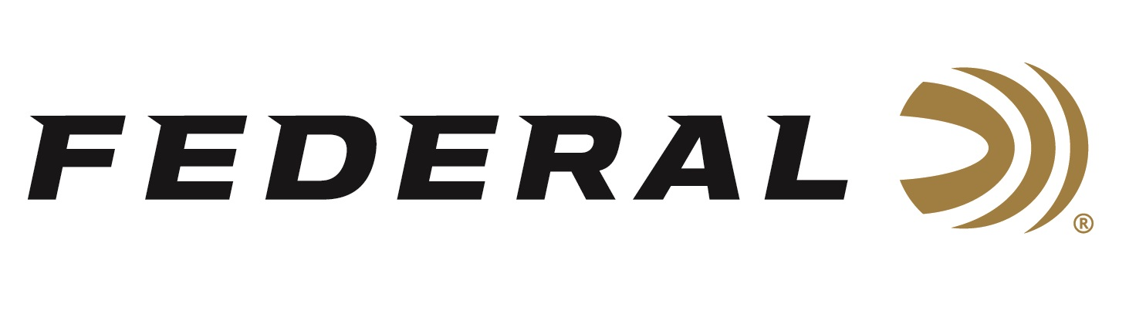

FOR IMMEDIATE RELEASE

Federal Ammunition Sponsored Shooters Performing Great across the World

ANOKA, Minnesota – October 7, 2019 – Federal Ammunition sponsored shooters continue to win accolades across all the shooting shooting sports both domestically and internationally. Impressive performances at top shooting events like the Grand American, IPSC European Handgun Championships, and PRS matches are putting valuable hardware in trophy cases.

Gregory Ferguson, Fort Morgan, Colorado had an amazing JR Gold performance at the Grand American, held annually in Sparta, IL. Using Top Gun from Federal Ammunition, Ferguson broke 1,200 of 1,200 16-yard targets and was perfect in eight individual events including winning the JR Gold AIM Championship and World Singles Championship.

Casey Reed, an ammunition engineer at Federal and competitive IPSC shooter, placed amongst the world’s best at the IPSC European Handgun Championships held in Belgrade, Serbia. The event held September 9-13, 2019 was host to more than a thousand athletes and presented twenty-four challenging stages at a special Serbian military base. Reed shoots Syntech Action Pistol 40 S&W, 205 grain in competition because it meets the power factor requirements for USPSA and IPSC competitions while providing reduced felt recoil for faster follow up shots.

Reed placed fourth overall in the Standard Division of the Championships behind competitors from the Phillippines and a fellow American. “The European Handgun Championship brings in the best competitors across the world to compete,” said Reed. “I appreciate the opportunity to compete and place amongst the best in the world, as well as represent Federal Ammunition and the United States. I hope to compete in the next one in 2023.”

Lastly, Hunter Sykes placed third in the PRS Federal Gold Medal Match Open Division held in Carbon Hill, Alabama held September 13, 2019. In tough competitions where performance and precision are measured in thousands of a second, Sykes relies on Gold Medal primers (GM205) for his handloads. A gold standard for primers, Gold Medal primers are built with exacting tolerances and strict quality ensuring shooters high quality components to build ammunition they can trust.

For more information on Federal ammunition, visit www.federalpremium.com.

Photo: Gregory Ferguson had an amazing performance at the Grand American.

Press Release Contact: JJ Reich
Senior Communications Manager - Firearms and Ammunition
E-mail: VistaPressroom@VistaOutdoor.com

About Federal Ammunition
Federal, headquartered in Anoka, MN, is a brand of Vista Outdoor Inc., an outdoor sports and recreation company. From humble beginnings nestled among the lakes and woods of Minnesota, Federal Ammunition has evolved into one of the world's largest producers of sporting ammunition. Beginning in 1922, founding president, Charles L. Horn, paved the way for our success. Today, Federal carries on Horn's vision for quality products and service with the next generation of outdoorsmen and women. We maintain our position as experts in the science of ammunition production. Every day we manufacture products to enhance our customers' shooting experience while partnering with the conservation organizations that protect and support our outdoor heritage. We offer thousands of options in our Federal Premium and Federal® lines-it's what makes us the most complete ammunition company in the business and provides our customers with a choice no matter their pursuit.

###

