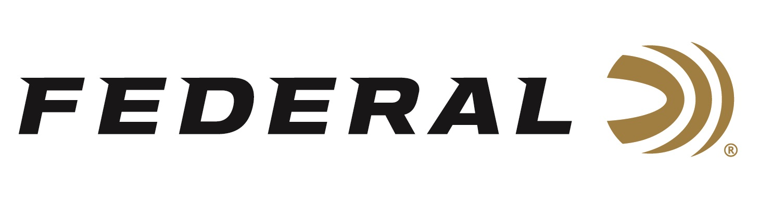

FOR IMMEDIATE RELEASE

Federal Strengthens Conservation and Youth Education Program Support with Dedicated Staff

ANOKA, Minnesota – August 28, 2019 – Federal Ammunition started its support of the 4-H Shooting Sports program more than 80 years ago. It is also the biggest proponent of conservation through on box royalty programs and a legacy of partnerships that started in 1935. The brand proudly announces the addition of Jon Zinnel as Conservation and Youth Shooting Program Manager to further this heritage.

Federal’s parent company Vista Outdoor, in its continuing mission to strengthen its consumer brands, has driven conservation program management back to its business units. For its Ammunition, this means dedicated youth shooting sports and conservation management for Federal and its sister brand CCI.

“Conservation is a critical part of our heritage and key to the future of our sport,” said Jason Vanderbrink, president of Federal. “Having a dedicated position at the factory will build on a legacy that started here more than 80 years ago and was solidified for 42 years under the late Bill Stevens. Our employees take great pride in giving back to wildlife, habitat and youth shooting programs and that will continue.”
Zinnel most recently served as Conservation and Youth Shooting Program Manager for Vista Outdoor, supporting multiple consumer brands from Federal and CCI to CamelBak and Champion Traps & Targets. He was part of growing partnerships with Scouting BSA, 4-H, IHEA and conservation programs from Pheasants Forever to National Wild Turkey Federation and many more.
Vista Outdoor, led by VP of Public Affairs Fred Ferguson, will continue to support organizations and causes that benefit the family of brands within the larger company.
Federal, headquartered in Anoka, MN, is a brand of Vista Outdoor Inc., an outdoor sports and recreation company. Federal Ammunition has evolved into one of the world's largest producers of sporting ammunition. We maintain our position as experts in the science of ammunition production. For more information on Federal ammunition, go to www.federalpremium.com.

Press Release Contact: JJ Reich
Senior Communications Manager - Ammunition
E-mail: VistaPressroom@VistaOutdoor.com

About Federal Ammunition
Federal, headquartered in Anoka, MN, is a brand of Vista Outdoor Inc., an outdoor sports and recreation company. From humble beginnings nestled among the lakes and woods of Minnesota, Federal Ammunition has evolved into one of the world's largest producers of sporting ammunition. Beginning in 1922, founding president, Charles L. Horn, paved the way for our success. Today, Federal carries on Horn's vision for quality products and service with the next generation of outdoorsmen and women. We maintain our position as experts in the science of ammunition production. Every day we manufacture products to enhance our customers' shooting experience while partnering with the conservation organizations that protect and support our outdoor heritage. We offer thousands of options in our Federal Premium and Federal lines—it’s what makes us the most complete ammunition company in the business and provides our customers with a choice no matter their pursuit.

###

