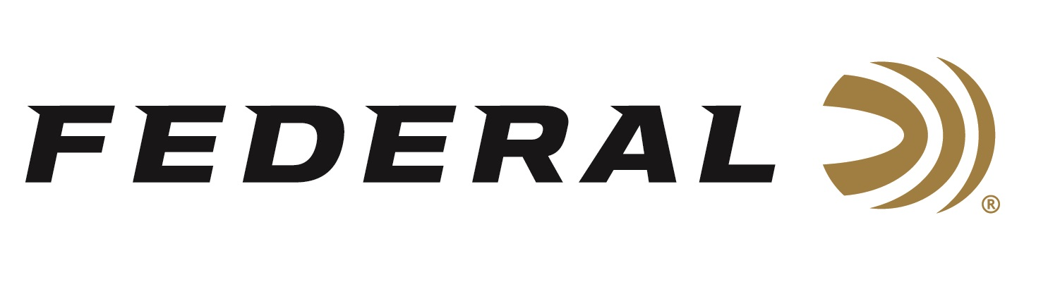

FOR IMMEDIATE RELEASE

Federal’s Industry-First Custom Shop for Ammunition Launches Online

ANOKA, Minnesota – October 24, 2019 – Federal is proud to introduce its new online custom-loaded ammunition shop. Customers can choose from several different specialized shotshell and centerfire rifle offerings, with a wide selection of the best bullets from Federal, Nosler, Sierra, Berger, Barnes and more. In addition, custom TSS Shotshells for turkey, waterfowl and upland game can be ordered. Orders are shipped direct to consumer.

“The Federal Custom Shop is an all-new way to deliver your preference of the perfect centerfire rifle or shotgun load built by our ammunition experts,” said Federal Ammunition President Jason Vanderbrink.

For example, at the time of the launch, centerfire rifle shooters can choose numerous bullets and from more than 10 different cartridges including 6.5-284 Norma, 257 Weatherby, 243 Winchester, 257 Roberts +P, 6.5 Creedmoor and more. Shotshell customers can custom order a large variety of loads including 10-gauge and 28-gauge. Shotgun Loads with unique payload sizes or loaded in 2-3/4 hulls for a lower recoil benefit are also possible. A lot of ammunition options exist at Federal’s Custom Shop that will appeal to customer personal preferences. However, the long list of options will change as the shop grows.

“If it’s not in Federal’s vast catalog as factory-loaded ammo, we may have it listed on our website as a load we will custom hand-load for you. We now have a specific selection of rifle and TSS shotshell loads that we will build on-demand, per order.” Vanderbrink said. “For example, Barnes 120-grain Tipped TSX in 6.5-284 Norma and 28-gauge TSS turkey loads aren’t products we list in our catalog, but you can certainly order them through our Custom Shop.”

Each Custom Shop round is painstakingly handloaded to order by our team of expert engineers in our state-of-the-art reloading workshop. These veteran craftsmen combine the best components with extra quality checks at every stage for the most consistent velocity, accuracy and overall performance. Loads are then hand-checked for final inspection and cleaned before being custom-packed in durable packaging signed by the engineer that hand-loaded it.

Made in the U.S.A., the Custom Shop handloading facility is located in a specialized room at Federal’s main factory in Anoka, Minnesota. The Custom Shop is not open to the public, and is an online, direct-to-consumer shop only. For more detailed information including how to order, what specific loads and options are available, shipping details, and more can be found by visiting www.federalpremium.com and click on “Custom Shop”.

Customers are also encouraged to watch Federal’s Custom Shop Promo Videos: http://www.federalpremium.com/custom-shop.

For more information on Federal ammunition and all its innovative products, visit www.federalpremium.com.

Press Release Contact: JJ Reich
Senior Communications Manager
E-mail: VistaPressroom@VistaOutdoor.com

About Federal Ammunition
Federal, headquartered in Anoka, MN, is a brand of Vista Outdoor Inc., an outdoor sports and recreation company. From humble beginnings nestled among the lakes and woods of Minnesota, Federal Ammunition has evolved into one of the world's largest producers of sporting ammunition. Beginning in 1922, founding president, Charles L. Horn, paved the way for our success. Today, Federal carries on Horn's vision for quality products and service with the next generation of outdoorsmen and women. We maintain our position as experts in the science of ammunition production. Every day we manufacture products to enhance our customers' shooting experience while partnering with the conservation organizations that protect and support our outdoor heritage. We offer thousands of options in our Federal Premium and Federal® lines-it's what makes us the most complete ammunition company in the business and provides our customers with a choice no matter their pursuit.

