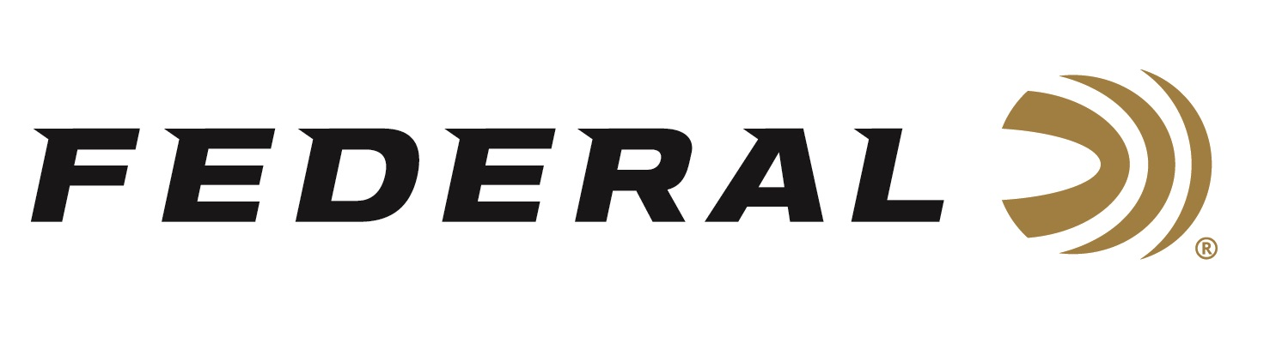

FOR IMMEDIATE RELEASE

Federal Ammunition and Ducks Unlimited Launch a Dedicated Partnership

ANOKA, Minnesota – October 23, 2019 – The world’s largest ammunition manufacturer is proud to announce a strong promotional partnership with Ducks Unlimited (DU). The arrangement includes Gold Sponsorship at the 2020 DU Expo hosted at Texas Motor Speedway May 15-17, 2020, as well as a promotional partnership with Federal Premium Black Cloud TSS ammunition.

“Our Proud Partner program is comprised of industry-leading companies and Federal Ammunition is no exception,” said Jim Alexander, DU’s managing Director of Corporate Relations. “We are happy to announce that Federal has agreed to participate as a Gold Sponsor at the 2020 DU Expo. Federal is an iconic brand, with a long history of dedication to conservation efforts, and we are extremely excited about this announcement.”

Ducks Unlimited Inc. is the world's largest nonprofit organization dedicated to conserving North America's continually disappearing waterfowl habitats. Established in 1937, Ducks Unlimited has conserved more than 14.5 million acres thanks to contributions from more than a million supporters across the continent. Guided by science and dedicated to program efficiency, DU works toward the vision of wetlands sufficient to fill the skies with waterfowl today, tomorrow and forever. For more information on our work, visit www.ducks.org.

“We chose to partner with DU because we share in looking toward the future of hunting, shooting and wildlife management along with leading conservation, restoration and wetland management efforts,” said Federal’s President, Jason Vanderbrink. “Federal’s support will contribute greatly to DU’s mission to conserve, restore and manage wetlands and associated habitats for North America’s waterfowl. I am certain this partnership help create long-lasting environmental improvements for future generations to come.”

Black Cloud TSS carries on a lethal legacy, blending proven FLITESTOPPER® Steel pellets and 18 g/cc Tungsten Super Shot. With 56 percent higher density than lead and more than double the density of steel, TSS pellets maintain velocity farther, hit harder and penetrate deeper than any waterfowl payload ever has. The swarm of shot leaves no chance for escape with the FLITECONTROL FLEX™ wad, which opens from the rear for a controlled release of the payload and the deadliest, most consistent patterns.
For more information on Federal ammunition and all its innovative products, visit www.federalpremium.com.

Press Release Contact: JJ Reich
Senior Communications Manager - Firearms and Ammunition
E-mail: VistaPressroom@VistaOutdoor.com

About Federal Ammunition
Federal, headquartered in Anoka, MN, is a brand of Vista Outdoor Inc., an outdoor sports and recreation company. From humble beginnings nestled among the lakes and woods of Minnesota, Federal Ammunition has evolved into one of the world's largest producers of sporting ammunition. Beginning in 1922, founding president, Charles L. Horn, paved the way for our success. Today, Federal carries on Horn's vision for quality products and service with the next generation of outdoorsmen and women. We maintain our position as experts in the science of ammunition production. Every day we manufacture products to enhance our customers' shooting experience while partnering with the conservation organizations that protect and support our outdoor heritage. We offer thousands of options in our Federal Premium and Federal® lines-it's what makes us the most complete ammunition company in the business and provides our customers with a choice no matter their pursuit.

###

