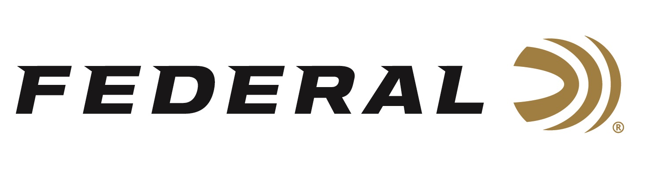

FOR IMMEDIATE RELEASE

Federal Recognized as Today’s Top Handgun Ammunition Brand

ANOKA, Minnesota – March 1, 2019 – A recent report conducted by Southwick Associates identifies Federal as the top handgun ammunition brand in today’s marketplace. Federal, including sub-brands like Fusion, came out on top after Southwick Associates surveyed more than 18,000 hunters and recreational shooters in 2018 through its online HunterSurvey.com and ShooterSurvey.com consumer panels.

“This report confirms we’ve accomplished what we’ve always worked hard to achieve,” said Federal Centerfire Rifle and Handgun Product Director Mike Holm. “Our handgun ammunition offers consistent, accurate performance for all types of recreational shooting, hunting and self-defense.”

Federal’s latest handgun ammunition introductions include the new 10mm Auto HST and Hydra-Shok Deep 40 S&W and 45 Auto. The 10mm Auto’s full-power loading makes the most of the HST bullet design, providing large, consistent expansion, optimum penetration and superior terminal performance. Hydra-Shok Deep bullets feature a more robust center post and a core design that penetrates to critical depths through common self-defense barriers, without over-penetrating.

More than 100 products were examined in the Southwick Associates 2018 Hunting & Shooting Participation and Equipment Purchases Report. Southwick’s in-depth resources illustrate shopping behaviors, such as where consumers buy, brand preferences, and amount spent. Learn more at www.southwickassociates.com.

For more information on Federal ammunition, visit www.federalpremium.com.

Press Release Contact: JJ Reich
Senior Communications Manager - Firearms and Ammunition
E-mail: VistaPressroom@VistaOutdoor.com

About Federal Ammunition
Federal, headquartered in Anoka, MN, is a brand of Vista Outdoor Inc., an outdoor sports and recreation company. From humble beginnings nestled among the lakes and woods of Minnesota, Federal Ammunition has evolved into one of the world's largest producers of sporting ammunition. Beginning in 1922, founding president, Charles L. Horn, paved the way for our success. Today, Federal carries on Horn's vision for quality products and service with the next generation of outdoorsmen and women. We maintain our position as experts in the science of ammunition production. Every day we manufacture products to enhance our customers' shooting experience while partnering with the conservation organizations that protect and support our outdoor heritage. We offer thousands of options in our Federal Premium and Federal lines-it's what makes us the most complete ammunition company in the business and provides our customers with a choice no matter their pursuit.

###

