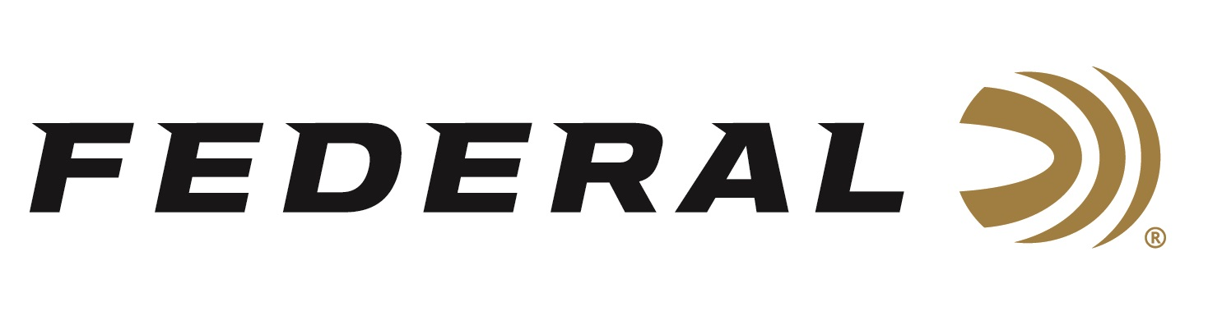

FOR IMMEDIATE RELEASE

Sporting Classics Magazine Honors Federal Ammunition with Excellence Award

ANOKA, Minnesota – March 5, 2019 – Sporting Classics magazine recently recognized Federal Ammunition as part of the magazine’s 17th annual Awards of Excellence. The program salutes the best of the best—companies and individuals whose products and services are having a significant and long-lasting impact on our sporting lives.

“From the very first color-coded shotshells in 1960, to Olympic-winning .22 rimfire ammo in the 1990s, to the new 224 Valkyrie centerfire in 2018, Federal has a rich history of innovation and quality,” said Sporting Classic spokesperson Ron Spomer. “In the mid-20th century, when most ammunition manufacturers were loading only their proprietary bullets, Federal had the foresight and temerity to offer hunters a Nosler Partition bullet in many popular calibers. Other premium bullets followed, giving hunters what they wanted instead of what Federal wanted them to want.”

“We are proud the editors of Sporting Classics presented Federal with this award,” said Federal Senior Marketing Director Jason Nash. “We strive to produce full product lines in centerfire, rimfire and shotshell. The result is a complete range of calibers, gauges, bullet weights, bullet types, shot sizes and more—options for all kinds of shooters.”

“Federal built the first commercial steel shotshells in the mid-1970s, Black Cloud waterfowl shells in 2007, Trophy Bonded Tip big game bullets in 2008, and resurrected many dangerous game big-bore cartridges like .470 Nitro Express,” continued Spomer. “Here in 2019, Federal offers shooters and hunters more choices in more calibers and gauges than any other major ammunition manufacturer, which is why we present Federal our Ammunition Award of Excellence.”

Nominees for the 2019 awards were submitted by Sporting Classics’ senior and contributing editors, then finalized by the magazine staff. The honorees were chosen for their achievements in defining what a great sporting product should be. Their engineering, craftsmanship and innovations have set higher standards than ever before. Awards were distributed during the 2019 SHOT Show in Las Vegas, Nevada.

For more information on Federal ammunition, visit www.federalpremium.com.

Press Release Contact: JJ Reich
Senior Communications Manager - Firearms and Ammunition
E-mail: VistaPressroom@VistaOutdoor.com

About Federal Ammunition
Federal, headquartered in Anoka, MN, is a brand of Vista Outdoor Inc., an outdoor sports and recreation company. From humble beginnings nestled among the lakes and woods of Minnesota, Federal Ammunition has evolved into one of the world's largest producers of sporting ammunition. Beginning in 1922, founding president, Charles L. Horn, paved the way for our success. Today, Federal carries on Horn's vision for quality products and service with the next generation of outdoorsmen and women. We maintain our position as experts in the science of ammunition production. Every day we manufacture products to enhance our customers' shooting experience while partnering with the conservation organizations that protect and support our outdoor heritage. We offer thousands of options in our Federal Premium and Federal® lines-it's what makes us the most complete ammunition company in the business and provides our customers with a choice no matter their pursuit.

###

