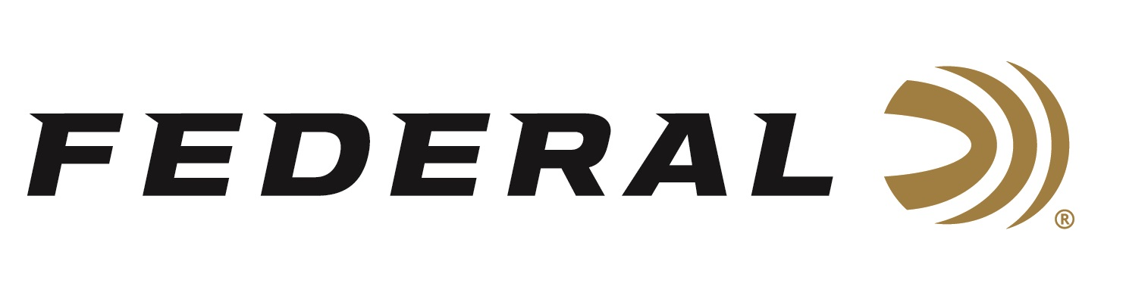

FOR IMMEDIATE RELEASE

Hydra-Shok Deep Takes 2019 Golden Bullseye Award for Ammunition Product of the Year

ANOKA, Minnesota – April 30, 2019 – The National Rifle Association’s (NRA) Shooting Illustrated magazine recently honored Federal Premium Hydra-Shok Deep with its Golden Bullseye Award for 2019 Ammunition Product of the Year. Federal Ammunition representatives accepted the award on April 26, during the 148th NRA Annual Meetings & Exhibits in Indianapolis, Indiana.

From the No. 1 brand in handgun ammunition, Hydra-Shok Deep bullets feature a more robust center post and a core design that penetrates to critical depths through common self-defense barriers, without over-penetrating. In fact, its updated bullet design penetrates 15 inches in bare ballistics gel and through heavy clothing—the optimal depth according to FBI standards. This results in a significant improvement in FBI protocol score.

“We are proud Hydra-Shok Deep was chosen for the prestigious award,” said Federal Ammunition President Jason Vanderbrink. “To even be considered for a Golden Bullseye, the product must meet a variety of demanding criteria on design, function, value and reliability. We are grateful they found the winner with Hydra-Shok Deep.”

Shooting Illustrated is the NRA's newest official journal, with a focus on concealed carry, self-defense and tactical shooting. For its Golden Bullseye Award program, the magazine’s staff considers only products that are available to the public and meet or exceeded its testing-and-evaluation protocols. Candidates must offer a unique value to the American shooting public, whether by innovation, affordability or other stand-out qualifications.

Hydra-Shok Deep was initially launched in 9mm Luger 135-grain. Recently, it has also been released in 40 S&W 165-grain and 45 Auto 210-grain, in 20-count packs.

For more information on Federal ammunition, visit www.federalpremium.com.

Press Release Contact: JJ Reich
Senior Communications Manager - Firearms and Ammunition
E-mail: VistaPressroom@VistaOutdoor.com
About Federal Ammunition
Federal, headquartered in Anoka, MN, is a brand of Vista Outdoor Inc., an outdoor sports and recreation company. From humble beginnings nestled among the lakes and woods of Minnesota, Federal Ammunition has evolved into one of the world's largest producers of sporting ammunition. Beginning in 1922, founding president, Charles L. Horn, paved the way for our success. Today, Federal carries on Horn's vision for quality products and service with the next generation of outdoorsmen and women. We maintain our position as experts in the science of ammunition production. Every day we manufacture products to enhance our customers' shooting experience while partnering with the conservation organizations that protect and support our outdoor heritage. We offer thousands of options in our Federal Premium and Federal® lines-it's what makes us the most complete ammunition company in the business and provides our customers with a choice no matter their pursuit.

