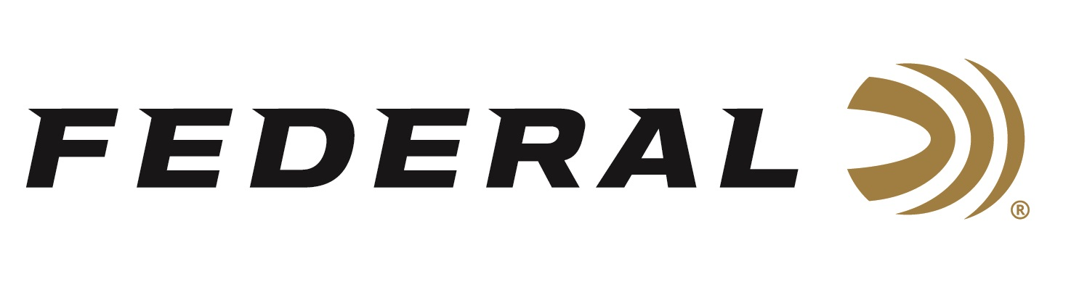

FOR IMMEDIATE RELEASE

NRA Shooting Illustrated Magazine Honors
Federal Premium Hydra-Shok Deep with “2019 Ammunition of the Year” Golden Bullseye Award

ANOKA, Minnesota – January 17, 2019 –The National Rifle Association’s (NRA) Shooting Illustrated magazine will recognize Federal Premium Hydra-Shok Deep with its Golden Bullseye Award for 2019 Ammunition Product of the Year. Federal Ammunition representatives will accept the honor during 148th NRA Annual Meetings and Exhibits, April 26 to 28, 2019, in Indianapolis, Indiana.

“We are extremely proud Hydra-Shok Deep was chosen for the prestigious award,” said Federal Ammunition President Jason Vanderbrink. “To even be considered for a Golden Bullseye, the product must meet a variety of demanding criteria on design, function, value and reliability. We are grateful they found the winner with Hydra-Shok Deep.”

Shooting Illustrated is the NRA's newest official journal, with a focus on concealed carry, self-defense and tactical shooting. For its Golden Bullseye Award program, the magazine’s staff considers only products that are available to the public and meet or exceeded its testing-and-evaluation protocols. Candidates must offer a unique value to the American shooting public, whether by innovation, affordability or other stand-out qualifications.

"Every round of Federal Premium Hydra-Shok Deep I tested penetrated between 15 and 16 inches, and expanded to at least 1.45 times its original diameter. Considering bullets weights ranged in weight from 135 to 210 grains, and in diameters from .356 to .45, that’s quite impressive,” said Shooting Illustrated ammo editor Richard Mann. “Federal also supplied me with 100 rounds of each load for follow-up testing. Terminal performance is one thing, but reliability is another. You can have the best bad guy-stopping bullet in the world, but if it will not cycle and feed in your handgun, all you can really count on is one shot. I tested these loads by firing one box each in a variety of handguns, including a Smith & Wesson M&P, several 1911s and Glocks, a Browning Hi Power and the new SIG Sauer P365. There were no stoppages or failures to fire.”

“Hydra-Shok Deep has quickly become a favorite of those who rely on ammunition to protect themselves and their families,” continued Vanderbrink. “Those shooters can take solace in knowing a longtime self-defense staple has been adapted and enhanced to meet 21st century challenges. We couldn’t be more pleased about this new ammunition being recognized by the industry for its improved penetration and superior reliability.”

Hydra-Shok Deep was initially launched in 9mm Luger 135-grain. Recently, it has also been released in 40 S&W 165-grain and 45 Auto 210-grain, in 20-count packs. All will be on display during the 2019 SHOT Show (Booth No. 14551), January 22-25, 2019 at the Sands Expo Center in Las Vegas, Nevada.

For more information on Federal ammunition, visit www.federalpremium.com.

Press Release Contact: JJ Reich
Senior Communications Manager - Firearms and Ammunition
E-mail: VistaPressroom@VistaOutdoor.com

About Federal Ammunition
Federal, headquartered in Anoka, MN, is a brand of Vista Outdoor Inc., an outdoor sports and recreation company. From humble beginnings nestled among the lakes and woods of Minnesota, Federal Ammunition has evolved into one of the world's largest producers of sporting ammunition. Beginning in 1922, founding president, Charles L. Horn, paved the way for our success. Today, Federal carries on Horn's vision for quality products and service with the next generation of outdoorsmen and women. We maintain our position as experts in the science of ammunition production. Every day we manufacture products to enhance our customers' shooting experience while partnering with the conservation organizations that protect and support our outdoor heritage. We offer thousands of options in our Federal Premium and Federal® lines-it's what makes us the most complete ammunition company in the business and provides our customers with a choice no matter their pursuit.

###

