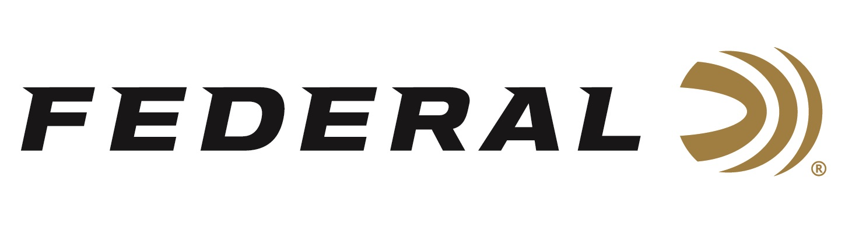

FOR IMMEDIATE RELEASE

On Target Magazine Honors Federal Premium Hydra-Shok Deep with Editors’ Choice Award

ANOKA, Minnesota – February 1, 2019 – On Target magazine recently recognized Federal Premium Hydra-Shok Deep with an Editors’ Choice Award for best-of-the-best in ammunition, as part of the magazine’s 17th annual awards program. The redesigned bullet delivers improved penetration to optimal depths and significantly higher FBI protocol scores—both helped the new self-defense ammunition earn the title.

“We are proud the editors of On Target presented Hydra-Shok Deep with this award,” said Federal Centerfire Product Director Mike Holm. “This ammunition features an improved version of Hydra-Shok’s iconic center post design for better, more consistent expansion through standard barriers. It is manufactured using consistent, specially formulated propellant and our extremely reliable Federal primers. We know the magazine’s readers will appreciate these improvements as they rely upon it every day.”

The design changes in Hydra-Shok Deep better meet modern performance measurements. The bullets feature a more robust center post and a core design that penetrates to critical depths through common self-defense barriers, without over-penetrating.

On Target is one of the leading publications in the shooting sports industry. Its staff tests and reviews guns, ammunition and hunting products, and presents the results in a straightforward, no-nonsense format that provides all the information consumers need to make purchase decisions. The print version of On Target can be picked up free at any of the nearly 2,000 firearm and hunting product retailers nationwide that distribute the magazine.

The On Target Editors’ Choice Awards are reserved for the best of the best new products—those which demonstrate outstanding technical achievement or represent an extraordinary value for the money.

Hydra-Shok Deep was initially launched in 9mm Luger 135-grain. Recently, it has also been released in 40 S&W 165-grain and 45 Auto 210-grain, in 20-count packs.

For more information on Federal ammunition, visit www.federalpremium.com.

Press Release Contact: JJ Reich
Senior Communications Manager - Firearms and Ammunition
E-mail: VistaPressroom@VistaOutdoor.com

About Federal Ammunition
Federal, headquartered in Anoka, MN, is a brand of Vista Outdoor Inc., an outdoor sports and recreation company. From humble beginnings nestled among the lakes and woods of Minnesota, Federal Ammunition has evolved into one of the world's largest producers of sporting ammunition. Beginning in 1922, founding president, Charles L. Horn, paved the way for our success. Today, Federal carries on Horn's vision for quality products and service with the next generation of outdoorsmen and women. We maintain our position as experts in the science of ammunition production. Every day we manufacture products to enhance our customers' shooting experience while partnering with the conservation organizations that protect and support our outdoor heritage. We offer thousands of options in our Federal Premium and Federal® lines-it's what makes us the most complete ammunition company in the business and provides our customers with a choice no matter their pursuit.

###

