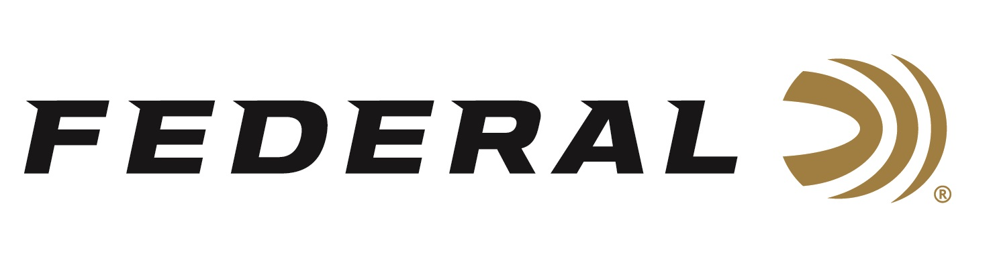

FOR IMMEDIATE RELEASE

Federal Sponsored Shooter Kurt Miller Takes Home High Honors at the 2019 IPSC World Rifle Championships

ANOKA, Minnesota – August 16, 2019 – Federal Ammunition congratulates sponsored shooter Kurt Miller for winning High Super Senior (60+) title at the 2019 IPSC World Rifle Championships. The event was held in Karlskoga, Sweden, August 3-10.

The championship provided visiting athletes with high-level sport shooting challenges. The match consisted of 30 stages over six days, and over 650 competitors from all over the world. Miller’s team also took home 3rd place in the standard semi-auto (iron sights only) division.

“The Federal ammunition I used shot flawlessly and allowed me the confidence in calling my shots at the extended ranges,” said Miller. “The stages stressed accuracy and long range shooting. They had paper targets out to 350 meters and steel targets out to 400 meters. The stages also challenged us with low ports, contorted positions, and a lot of off-hand shooting. It was an honor to be part of the United States national team and to represent Federal.”

The International Practical Shooting Confederation (IPSC) was established to promote, maintain, improve and advance the sport of practical shooting, to safeguard its principles and to regulate its conduct worldwide for the safe, recreational use of firearms by persons of good character. Learn more at: www.ipsc.org.

Federal is a proud sponsor of many competitive shooters in several disciplines. Federal is the official Ammunition Partner of the Precision Rife Series, and the official shotshell ammunition sponsor and supplier of USA Shooting, a non-profit organization that promotes the shooting sports and prepares American athletes to bring home Olympic gold.

Learn more at Federal and all its ammunition products by visiting www.federalpremium.com.

Press Release Contact: JJ Reich
Senior Communications Manager - Firearms and Ammunition
E-mail: VistaPressroom@VistaOutdoor.com

About Federal Ammunition
Federal, headquartered in Anoka, MN, is a brand of Vista Outdoor Inc., an outdoor sports and recreation company. From humble beginnings nestled among the lakes and woods of Minnesota, Federal Ammunition has evolved into one of the world's largest producers of sporting ammunition. Beginning in 1922, founding president, Charles L. Horn, paved the way for our success. Today, Federal carries on Horn's vision for quality products and service with the next generation of outdoorsmen and women. We maintain our position as experts in the science of ammunition production. Every day we manufacture products to enhance our customers' shooting experience while partnering with the conservation organizations that protect and support our outdoor heritage. We offer thousands of options in our Federal Premium and Federal® lines-it's what makes us the most complete ammunition company in the business and provides our customers with a choice no matter their pursuit.

