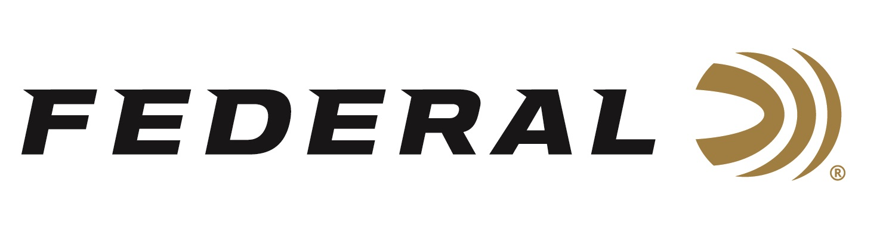

FOR IMMEDIATE RELEASE

Federal Ammunition to Launch Exclusive Line of MeatEater Ammunition

ANOKA, Minnesota – October 22, 2019 – Federal Ammunition, the world’s largest ammunition manufacturer, announced the forthcoming launch of an exclusive line of ammunition in partnership with MeatEater. This new line of ammunition will be available in stores starting January 2020.

MeatEater is a media company and lifestyle brand founded by renowned outdoorsman, TV and podcast host, and conservationist Steven Rinella. Federal Ammunition’s MeatEater line will include centerfire, shotshell, and rimfire ammunition that delivers on the expectation of premium performance for all hunting disciplines.

“The MeatEater brand and Federal Ammunition are a great match,” said Federal Ammunition’s President Jason Vanderbrink. “The connection Steven Rinella has with his dedicated audience is on par with Federal’s history and heritage within the hunting community.”

MeatEater’s passionate fan base is already well acquainted with the field to table ethos that is at the center of the brand’s content, from podcasts and TV to articles and social media. To match that core value, every centerfire box of MeatEater ammunition will include a favorite recipe from MeatEater’s experienced kitchen.

“I’ve used Federal Ammunition for most of my life because it’s the best on the market,” said Steven Rinella. “Our whole team is excited to be partnering with the brand we depend on for quality and consistency in the field, which leads to quality and consistency in the meals we share with our familes.”

Initially, Federal Ammunition will launch the MeatEater line of ammunition with the proprietary Trophy Copper centerfire ammunition. The line will feature eighteen calibers ranging from .223 to 338 Lapua Magnum and will include popular offerings in 6.5 Creedmoor, .270 Win, 30-06, and 300 Win Mag. The comprehensive line will include turkey loads, bismuth offerings for waterfowl and upland enthusiasts, and rimfire products for plinking and small game hunting.

For more information on Federal ammunition, visit www.federalpremium.com.

Press Release Contact: JJ Reich
Senior Communications Manager - Firearms and Ammunition
E-mail: VistaPressroom@VistaOutdoor.com

About Federal Ammunition
Federal, headquartered in Anoka, MN, is a brand of Vista Outdoor Inc., an outdoor sports and recreation company. From humble beginnings nestled among the lakes and woods of Minnesota, Federal Ammunition has evolved into one of the world's largest producers of sporting ammunition. Beginning in 1922, founding president, Charles L. Horn, paved the way for our success. Today, Federal carries on Horn's vision for quality products and service with the next generation of outdoorsmen and women. We maintain our position as experts in the science of ammunition production. Every day we manufacture products to enhance our customers' shooting experience while partnering with the conservation organizations that protect and support our outdoor heritage. We offer thousands of options in our Federal Premium and Federal® lines-it's what makes us the most complete ammunition company in the business and provides our customers with a choice no matter their pursuit.

###

