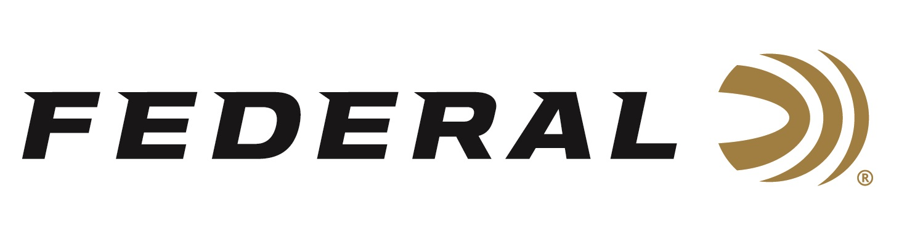

FOR IMMEDIATE RELEASE

Federal Ammunition Makes Big Announcements at the 2019 NRA Annual Meetings & Exhibits

ANOKA, Minnesota – April 22, 2019 – Federal Ammunition will unveil unique consumer experiences and innovative products at the NRA Annual Meetings & Exhibits in Indianapolis, Indiana, April 26-28, 2019. Attendees are encouraged to visit booth 4955 to see all its new products and get a sneak peek into the launch of Federal’s revolutionary “Custom Ammo Shop,” coming this summer. Booth visitors can experience it all while enjoying a free coffee sample from one of the brand’s newest partners, Black Rifle Coffee Company (BRCC).

Federal’s lineup of new products includes three loads in 350 Legend: 160-grain Fusion bonded soft point, 180-grain Power-Shok soft point and 180-grain Non-Typical soft point. The cartridge offers higher velocities than any straight-wall deer cartridge, with significantly less recoil than 450 Bushmaster in a compact, maneuverable platform. It’s an ideal fit for both MSRs and bolt-action rifles, penetrates deep and delivers ample energy to take down any buck. Plus, it’s legal for hunting in many areas bottleneck centerfire rifle cartridges are prohibited. The loads will be available this summer in 20-count packs with MSRPs from $26.95 to $32.95.

Federal’s Custom Shop is coming soon and will give consumers the opportunity to order ammunition built specifically to their preferences. Custom Shop ammunition consists of products not listed in the catalog. Several centerfire rifle offerings from a wide selection of bullet and caliber options, as well as shotshell loads including many Tungsten Super Shot (TSS) options for hunting, will be available for the initial launch.

The Custom Shop is scheduled to open for business this summer. Federal asks those not attending the NRA Annual Meetings & Exhibits to sign-up for its enewsletter for updates on when the Custom Shop will open and for specific options that will be available. Visit the Federal homepage, scroll down to the bottom and click “Get the Latest” to sign up.

Federal also welcomes Black Rifle Coffee Company to its booth. It’s excited to align with the popular brand, which supports the shooting and hunting industry and 2nd Amendment rights. Federal invites attendees to stop by and sample the variety of coffee, shop for roasted beans or other BRCC merchandise, and much more.

Information on new products and services from Federal will be available and on display at the NRA Annual Meetings & Exhibits. For more general information on Federal ammunition, visit www.federalpremium.com.

Press Release Contact: JJ Reich
Senior Communications Manager - Firearms and Ammunition
E-mail: VistaPressroom@VistaOutdoor.com

About Federal Ammunition
Federal, headquartered in Anoka, MN, is a brand of Vista Outdoor Inc., an outdoor sports and recreation company. From humble beginnings nestled among the lakes and woods of Minnesota, Federal Ammunition has evolved into one of the world's largest producers of sporting ammunition. Beginning in 1922, founding president, Charles L. Horn, paved the way for our success. Today, Federal carries on Horn's vision for quality products and service with the next generation of outdoorsmen and women. We maintain our position as experts in the science of ammunition production. Every day we manufacture products to enhance our customers' shooting experience while partnering with the conservation organizations that protect and support our outdoor heritage. We offer thousands of options in our Federal Premium and Federal® lines-it's what makes us the most complete ammunition company in the business and provides our customers with a choice no matter their pursuit.

