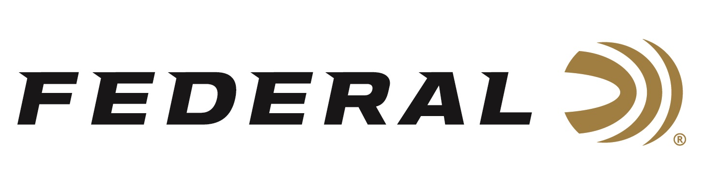

FOR IMMEDIATE RELEASE

Federal Ammunition Sponsored Shooter Continues Winning Streak in the Tactical Division of PRS

ANOKA, Minnesota – Oct 29, 2019 – Team Federal shooter Buck Holly continues his reign in the Tactical Division of the Precision Rifle Series (PRS) Championship Shooting Series. Besting the field of more than one hundred competitors, Holly recently won the Tactical Division and tied for 5th overall in the Open Division at the Kestrel Fall Classic Competition in Baker, Florida. This marks Holly’s 11th win of the season.

Holly is currently ranked as the top tactical division shooter in the country. One of the Georgia native’s secrets to success is his trust in Federal ammunition.

“The entire match was redesigned with new shooting positions and target locations. The competition was a true test of shooters gear and wind reading skills. The rain and the winds were often brutal,” said Holly. “I shoot the factory-loaded 175 grain Federal Premium Gold Medal Sierra MatchKing in 308 Win, which did exceptional in these conditions. This load gives me the performance I expect and helped me finish on top.”

The legendary, precision-built Sierra MatchKing bullet has long been an industry standard for match accuracy. Federal’s exclusive primer design provides the best sensitivity and most consistent ballistics in the industry. These and other features of Federal ammunition are critical to competition success and makes it the best choice for the world’s most elite shooters.

PRS Pro Series and PRS Club Series matches involve the practical application of long-range rifle shooting born out of military, law-enforcement and hunting scenarios. Learn more at www.precisionrifleseries.com.

Federal is the official Ammunition Partner of the Precision Rife Series. Learn more at Federal and all its ammunition products by visiting www.federalpremium.com.

Press Release Contact: JJ Reich
Senior Communications Manager - Firearms and Ammunition
E-mail: VistaPressroom@VistaOutdoor.com

About Federal Ammunition
Federal, headquartered in Anoka, MN, is a brand of Vista Outdoor Inc., an outdoor sports and recreation company. From humble beginnings nestled among the lakes and woods of Minnesota, Federal Ammunition has evolved into one of the world's largest producers of sporting ammunition. Beginning in 1922, founding president, Charles L. Horn, paved the way for our success. Today, Federal carries on Horn's vision for quality products and service with the next generation of outdoorsmen and women. We maintain our position as experts in the science of ammunition production. Every day we manufacture products to enhance our customers' shooting experience while partnering with the conservation organizations that protect and support our outdoor heritage. We offer thousands of options in our Federal Premium and Federal® lines-it's what makes us the most complete ammunition company in the business and provides our customers with a choice no matter their pursuit.

