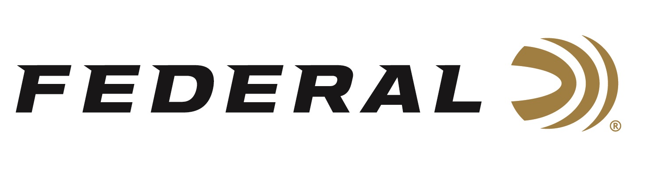

FOR IMMEDIATE RELEASE

The Gold Rush continues for Federal Sponsored Shooter
Ashley Carroll

ANOKA, Minnesota – July 30, 2019 – Federal Ammunition sponsored shooter Ashley Carroll continues her summer of success in women’s trap with a Pan American Games Gold Medal in Lima, Peru. "I couldn’t be more excited to be coming home with a Pan Am medal, especially since this is my first time competing in a Pan American Games," Carroll said. This latest title for Carroll comes less than thirty days after striking gold in Women’s Trap at the World Championships.

Carroll, the top Women’s Trap athlete in the world, qualified for the Pan American finals with an impressive 120/125. Carroll would cruise to a finals victory ahead of fellow American Rachel Tozier. With a summer of great performances led by Carroll, the USA Women’s Trap team has qualified its two spots for the Olympics next summer in Tokyo.

Serious shooters have long relied on Federal Premium Gold Medal shotshells to dominate the competition in trap, skeet and sporting clay events worldwide. Year after year, Gold Medal rounds earn the respect of all levels of competitive shooters. The enhanced design of new Gold Medal Grand shotshells, introduced in 2017, builds on that tradition with less felt recoil, more reliable ignition, improved patterns, harder shot and maximum downrange power. The USA Shooting logo is also proudly displayed on boxes of Federal Premium Gold Medal Grand.

Federal is the official shotshell ammunition sponsor and supplier of USA Shooting, a non-profit organization that promotes the shooting sports and prepares American athletes to bring home Olympic gold. Learn more about USA Shooting at: www.usashooting.org. For more information on Federal ammunition, visit www.federalpremium.com.

Press Release Contact: JJ Reich
Senior Communications Manager - Firearms and Ammunition
E-mail: VistaPressroom@VistaOutdoor.com

About Federal Ammunition
Federal, headquartered in Anoka, MN, is a brand of Vista Outdoor Inc., an outdoor sports and recreation company. From humble beginnings nestled among the lakes and woods of Minnesota, Federal Ammunition has evolved into one of the world's largest producers of sporting ammunition. Beginning in 1922, founding president, Charles L. Horn, paved the way for our success. Today, Federal carries on Horn's vision for quality products and service with the next generation of outdoorsmen and women. We maintain our position as experts in the science of ammunition production. Every day we manufacture products to enhance our customers' shooting experience while partnering with the conservation organizations that protect and support our outdoor heritage. We offer thousands of options in our Federal Premium and Federal® lines-it's what makes us the most complete ammunition company in the business and provides our customers with a choice no matter their pursuit.

