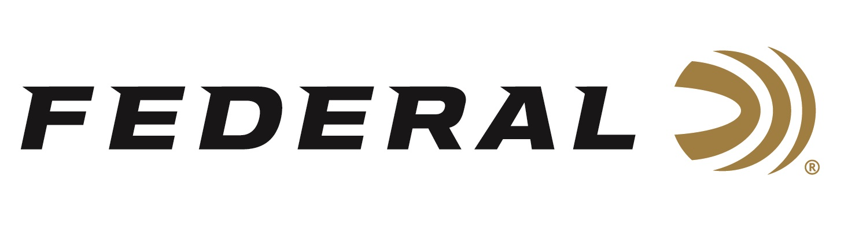

FOR IMMEDIATE RELEASE

Federal Ammunition Sponsored USA Shooting Team Athletes Continue to Shoot Strong and Win Major Championships

ANOKA, Minnesota – May 1, 2019 – Federal Premium Ammunition sponsored shooters and brand Ambassadors Vincent Hancock, Kayle Browning, Ashley Carroll, and more are busting clays, competing strong, winning medals and finishing on top at the major shooting competition events worldwide. A key victory being Hancock winning the gold medal at the recent 2019 International Shooting Sports Federation (ISSF) World Cup.

The two-time Olympic gold medalist and reigning World Champion finished the Men’s Skeet competition at the ISSF World Cup in Acapulco, Mexico with a perfect score in Qualification (125/125 targets). He capped it off with a perfect score in the Final as well (60/60 targets). This outstanding accomplishment equals the world record and helped him claim his 11th World Cup gold medal.

The Trap Mixed Team of Federal Pro Staff shooter Kayle Browning and her partner Brian Burrows earned a silver medal at the same World Cup event. International Shooting Sport Federation (ISSF) World Cup in Acapulco, Mexico. The duo set a Qualification World Record of 149 targets, with Browning shooting a personal best of 75/75 targets. Once in the Final, Browning/Burrows hit 43/50 targets to win the silver medal.

Other Pro Staff competitors are off to a strong start this season. This includes trap competitor Ashley Carroll as she captured the individual gold medal in Women’s Trap competition during the USA Shooting Spring Selection Match. She then teamed with Derek Haldeman to earn top honors in the Mixed Team trap event as well. Skeet pro staff member Katie Jacob finished as the runner-up in junior competition at the USA Shooting Spring Selection match on March 9.

The USA Shooting Team will be back in action in Changwon, South Korea for another ISSF World Cup event beginning May 9 with Women’s Skeet.

Serious shooters have long relied on Federal Premium Gold Medal shotshells to dominate the competition in trap, skeet and sporting clay events worldwide. Year after year, Gold Medal rounds earn the respect of all levels of competitive shooters. The enhanced design of new Gold Medal Grand shotshells, introduced in 2017, builds on that tradition with less felt recoil, more reliable ignition, improved patterns, harder shot and maximum downrange power. The USA Shooting logo is also proudly displayed on boxes of Federal Premium Gold Medal Grand.

Federal is the official shotshell ammunition sponsor and supplier of USA Shooting, a non-profit organization that promotes the shooting sports and prepares American athletes to bring home Olympic gold. Learn more about USA Shooting at: www.usashooting.org. For more information on Federal ammunition, visit www.federalpremium.com.

Press Release Contact: JJ Reich
Senior Communications Manager - Firearms and Ammunition
E-mail: VistaPressroom@VistaOutdoor.com

About Federal Ammunition
Federal, headquartered in Anoka, MN, is a brand of Vista Outdoor Inc., an outdoor sports and recreation company. From humble beginnings nestled among the lakes and woods of Minnesota, Federal Ammunition has evolved into one of the world's largest producers of sporting ammunition. Beginning in 1922, founding president, Charles L. Horn, paved the way for our success. Today, Federal carries on Horn's vision for quality products and service with the next generation of outdoorsmen and women. We maintain our position as experts in the science of ammunition production. Every day we manufacture products to enhance our customers' shooting experience while partnering with the conservation organizations that protect and support our outdoor heritage. We offer thousands of options in our Federal Premium and Federal® lines-it's what makes us the most complete ammunition company in the business and provides our customers with a choice no matter their pursuit.

