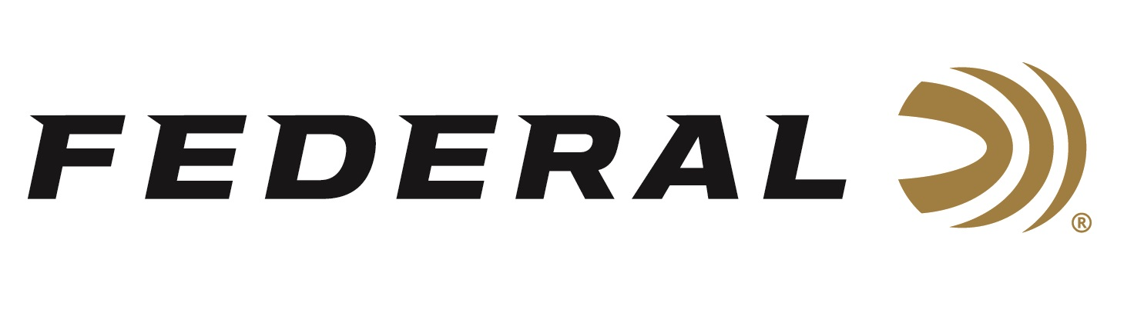

FOR IMMEDIATE RELEASE

Federal Ammunition Honored by NWTF with Corporate Achievement Award for More than 35 years of Continuous Support

ANOKA, Minnesota – February 25, 2019 – Federal, the only licensed ammunition partner of the National Wild Turkey Federation (NWTF), recently received NWTF’s Corporate Achievement Award. The award was presented to Federal’s Director of Conservation Ryan Bronson during the 43rd Annual NWTF Convention & Sport Show, February 13-17, 2019, in Nashville, Tennessee.

Presented annually by the NWTF, the Corporate Achievement Award recognizes the outstanding work and dedication corporate partners have displayed in conserving wildlife and habitat and preserving the hunting heritage.

Federal is one of the five longest-running sponsors of NWTF, having participated at every convention the organization has held, and hosting NWTF’s Conservation Breakfast for 37 years. Federal is the only company in the industry with an active conservation program, working on both policy and programs to protect, enhance and restore habitat across the country.

“Federal Ammunition exists today because conservation leaders had the forethought to protect and restore our wildlife decades ago,” said Bronson. “The National Wild Turkey Federation is a modern conservation powerhouse, and we are so grateful to have the opportunity to partner with them every day to put habitat on the ground and hunters in the field to keep this conservation legacy going in perpetuity.”

With turkey populations in great shape throughout much of the country, hunters anticipate a memorable 2019 season. Now they can go afield knowing Federal’s new Premium turkey loads will not only deliver consistent, devastating performance, but also help turkeys themselves through partnership with the NWTF.

“We support NWTF’s hunting heritage and conservation mission across the board,” said Bronson. “That’s why we print NWTF’s logo clearly on our Premium turkey packaging. This means a portion of the proceeds from each and every box sold is donated to the NWTF. We are extremely proud of that, because we are completely dedicated to conservation.”

For more information on Federal ammunition, visit www.federalpremium.com.

Press Release Contact: JJ Reich
Senior Communications Manager - Firearms and Ammunition
E-mail: VistaPressroom@VistaOutdoor.com

About Federal Ammunition
Federal, headquartered in Anoka, MN, is a brand of Vista Outdoor Inc., an outdoor sports and recreation company. From humble beginnings nestled among the lakes and woods of Minnesota, Federal Ammunition has evolved into one of the world's largest producers of sporting ammunition. Beginning in 1922, founding president, Charles L. Horn, paved the way for our success. Today, Federal carries on Horn's vision for quality products and service with the next generation of outdoorsmen and women. We maintain our position as experts in the science of ammunition production. Every day we manufacture products to enhance our customers' shooting experience while partnering with the conservation organizations that protect and support our outdoor heritage. We offer thousands of options in our Federal Premium and Federal lines-it's what makes us the most complete ammunition company in the business and provides our customers with a choice no matter their pursuit.

###

