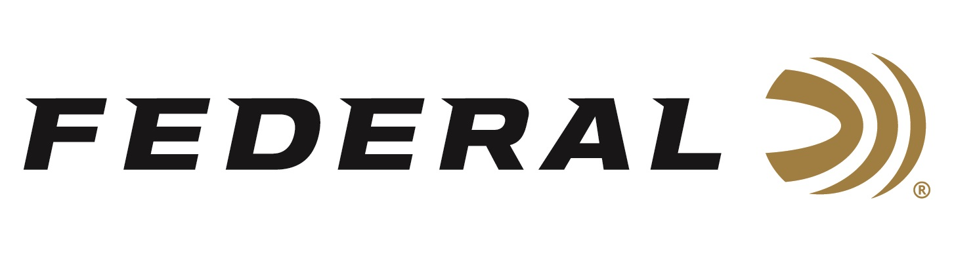

FOR IMMEDIATE RELEASE

Federal Ammunition Announces New Blended HEAVYWEIGHT TSS

ANOKA, Minnesota – January 16, 2019 – Federal, the only licensed ammunition partner of the National Wild Turkey Federation (NWTF), has expanded its HEAVYWEIGHT TSS lineup by adding loads with two sizes of shot to increase overall pellet count and number of hits on target. These new loads will be on display during the 2019 SHOT Show (Booth No. 14551), January 22-25 at the Sands Expo Center in Las Vegas, Nevada.

The offerings combine No. 7 and 9, or No. 8 and 10, Tungsten Super Shot to deliver the extremely high pellet counts and dense patterns turkey hunters are constantly striving to achieve. In fact, some of the payloads top 1,000 pellets.

Federal is adding two new 12-gauge, 3 ½-inch TSS blended options: a 2 ½-ounce No. 7/9 mix and a 2 ½-ounce No. 8/10 mix, each at an MSRP of $63.95. New 20-gauge offerings include two 3-inch loads: a 1 5/8-ounce No. 7/9 mix and a 1 5/8-ounce No. 8/10 mix at an MSRP of $46.95. The shells come in five-count packs.

With wild turkey population numbers in great shape throughout much of the country, hunters anticipate a memorable 2019 season. Now, they can go afield knowing Federal Premium’s new turkey loads will not only deliver consistent, devastating performance, but also help turkeys themselves through partnership with the NWTF.

“We support NWTF’s hunting heritage and conservation mission across the board,” said Federal Director of Conservation Ryan Bronson. “That’s why we print NWTF’s logo clearly on our Premium turkey packaging. This means a portion of the proceeds from each and every box sold is donated to the NWTF. We are extremely proud of that, because we are completely dedicated to conservation.”

For more information on Federal ammunition, visit www.federalpremium.com.

Press Release Contact: JJ Reich
Senior Communications Manager - Firearms and Ammunition
E-mail: VistaPressroom@VistaOutdoor.com
About Federal Ammunition
Federal, headquartered in Anoka, MN, is a brand of Vista Outdoor Inc., an outdoor sports and recreation company. From humble beginnings nestled among the lakes and woods of Minnesota, Federal Ammunition has evolved into one of the world's largest producers of sporting ammunition. Beginning in 1922, founding president, Charles L. Horn, paved the way for our success. Today, Federal carries on Horn's vision for quality products and service with the next generation of outdoorsmen and women. We maintain our position as experts in the science of ammunition production. Every day we manufacture products to enhance our customers' shooting experience while partnering with the conservation organizations that protect and support our outdoor heritage. We offer thousands of options in our Federal Premium and Federal lines-it's what makes us the most complete ammunition company in the business and provides our customers with a choice no matter their pursuit.

###

