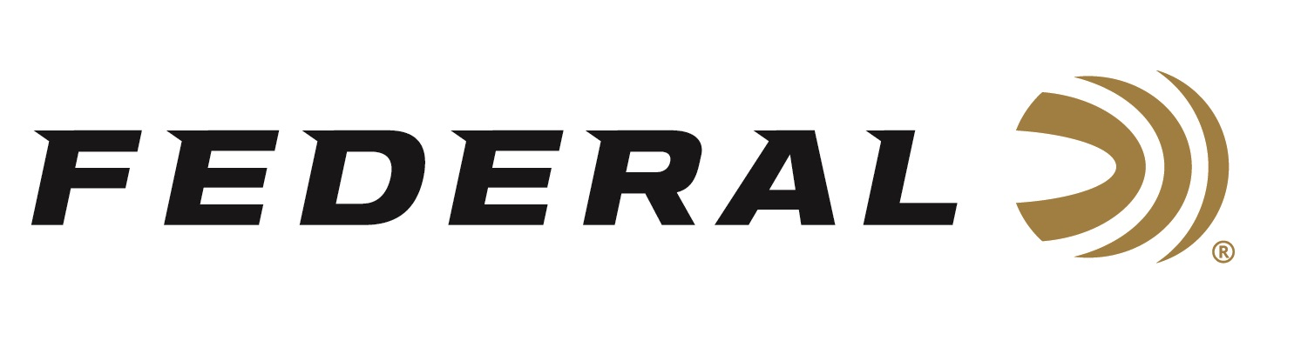

FOR IMMEDIATE RELEASE

Federal Congratulates All Sponsored Shooters on ‘Team Federal’ for a Great Year of Competition Success

ANOKA, Minnesota – December 18, 2019 – Team Federal reported a long list of great achievements over the past year. Federal Ammunition congratulates all its sponsored shooters and thanks them for their great support of the dependable and accurate products they rely on in competition. Members of Team Federal participate in many types of competition including Multi-Gun, PRS, USPSA and more at the national, state, regional and local levels.

“Federal is proud of all the members of Team Federal highlighted below for their 2019 accomplishments. We also congratulate and thank all our sponsored shooters for an action-packed year of competitive shooting,” said Shooting Sports Promotions and Field Training Manager Jason Spradling. “We are fortunate to partner with such dedicated and talented competition shooters from across the country, and we look forward to another outstanding year in 2020.”

For Multi-Gun competitions, sponsored shooter Jake Latola won the Tactical Optics division for the third year in a row at the Nordic Components and Vortex Optics Tri-Gun in Forest Lake, Minnesota. Sean Burrows had several top finishes throughout the year including the Safariland Expedition Multi-Gun Match in Boulder City, Nevada. Tony Holmes had several top finishes including 2nd in the Senior Open Division and 3rd place overall at the 3-Gun Championship in Grand Island, Nebraska. Kurt Miller won the High Super Senior (60+) title at the 2019 IPSC World Rifle Championships held in Karlskoga, Sweden. Chris Sechiatano earned several top finishes in several competitions including 1st place Limited Division at the 2019 Southwest Rimfire Challenge Championships in Piru, California.

In the Precision Rifle Series, Team Federal shooter Buck Holly recorded eleven total tactical division wins and finished second in the nation for the year. Team member Hunter Sykes recorded a strong 3rd place finish at the inaugural Federal Gold Medal Match held at Alabama Precision in September.

For Pistol, Rimfire and Steel Challenges, Cole Busch recently won two of the six divisions at the 2019 USPSA Area 5 Steel Challenge Championship, and 3rd Overall at the Riley Conservation Club in Riley, Indiana. Grant Kunkel had several top finishes including High Overall honors at the 2019 Lonestar Rimfire Challenge, Missouri State Steel Match and Mississippi State Steel Match. Matt Hopkins won many 1st place titles in the Production division including the Ozarks Classic, Rocky Mountain 300 and the Arkansas Section Championship. Tim Herron had several IPSC and USPSA top finishes including 1st place overall in the SS division at the Alaska, New Mexico, and Illinois USPSA Sectional Championships, as well as High Desert Classic in Albuquerque, New Mexico. Finally, Federal Ammunition employee, competition shooter and brand ambassador Casey Reed won the Minnesota State Championship and finished strong in several high-profile matches including second place honors in the Limited 10 Division at the USPSA Lo-Cap National Championship in Frostproof, Florida.

Federal is the official Ammunition Partner of the Precision Rife Series. Federal is also a sponsor of the USPSA, and Syntech Action Pistol is the official sponsored ammo of the organization, with their logo on the box. Learn more at Federal and all its ammunition products by visiting www.federalpremium.com.

Press Release Contact: JJ Reich
Senior Communications Manager - Firearms and Ammunition
E-mail: VistaPressroom@VistaOutdoor.com

About Federal Ammunition
Federal, headquartered in Anoka, MN, is a brand of Vista Outdoor Inc., an outdoor sports and recreation company. From humble beginnings nestled among the lakes and woods of Minnesota, Federal Ammunition has evolved into one of the world's largest producers of sporting ammunition. Beginning in 1922, founding president, Charles L. Horn, paved the way for our success. Today, Federal carries on Horn's vision for quality products and service with the next generation of outdoorsmen and women. We maintain our position as experts in the science of ammunition production. Every day we manufacture products to enhance our customers' shooting experience while partnering with the conservation organizations that protect and support our outdoor heritage. We offer thousands of options in our Federal Premium and Federal® lines-it's what makes us the most complete ammunition company in the business and provides our customers with a choice no matter their pursuit.

