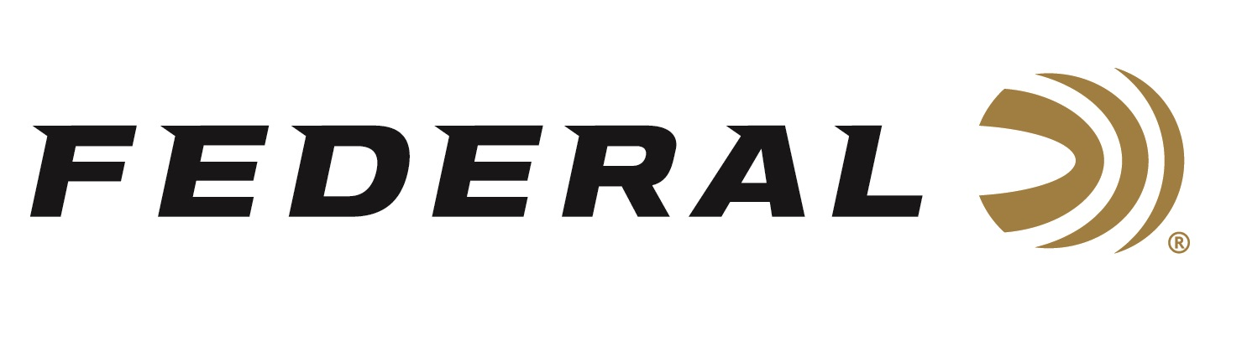

FOR IMMEDIATE RELEASE

Shotgun Shooters on Team Federal Enjoyed Another Great Year of Success in 2019

ANOKA, Minnesota – December 19, 2019 – The list of Team Federal competition wins for trap, skeet and sporting clays for 2019 is long and impressive. Season highlights include Todd Bender who was crowned the 2019 HOA World Skeet Champion and the 410 World Skeet Champion. Tank Lunsford won more than 30 Sub-Veteran state or regional championships, HOA and HAA trap titles. Janet McDougall won the 2019 NSCA US Open Championship for sporting clays.

Federal’s youngest competitive trap shooter Grayson Stuart was a standout on the team, competing in hundreds of events across the country and winning more than 70 top finishes in national, state and regional competitions. Highlights from 14-year-old’s season includes winning Sub-Junior Doubles and taking 3rd Place in Sub-Junior for HOA and HAA at the 2019 Grand American World Clay Target Championship in Sparta, Illinois. Grayson was also the HOA and HAA Sub-Junior Champion at Western Satellite Grand Competition in Vernal, Utah. Grayson was Team Captain for the Utah State Sub-Junior Team, USAYESS Sub-Junior Team, as well as other teams. Additionally, he was a 1st Team All-American Member of the ATA Sub-Junior Team for the 4th consecutive year.

“I want to say thanks to Federal for not only making award-winning shotshells, but for their continuous support and passion in not only me, but the shooting sports themselves,” said Stuart. “Federal Ammunition has pushed me up mountains I never thought I could climb.”

“We look to young shooters like Grayson to help energize trap shooting to the younger generations,” said Federal Youth Shooting Sports Program Manager Jon Zinnel. “Grayson did an outstanding job representing the Federal brand. His performance was great to watch throughout the year because it was obvious that he had fun and enjoyed sharing that excitement with others. We congratulate him on his impressive list of accomplishments in 2019 and look forward to seeing him excel in 2020 and beyond.”

Federal is the official shotshell ammunition sponsor and supplier of USA Shooting, a non-profit organization that promotes the shooting sports and prepares American athletes to bring home gold. Federal is also a large supporter of the Amateur Trap Association (ATA), National Skeet Shooters Association (NSSA), National Sporting Clays Association (NSCA), and many other national, regional and state shooting sports organizations. Learn more at Federal and all its ammunition products by visiting www.federalpremium.com.

Press Release Contact: JJ Reich
Senior Communications Manager - Firearms and Ammunition
E-mail: VistaPressroom@VistaOutdoor.com

About Federal Ammunition
Federal, headquartered in Anoka, MN, is a brand of Vista Outdoor Inc., an outdoor sports and recreation company. From humble beginnings nestled among the lakes and woods of Minnesota, Federal Ammunition has evolved into one of the world's largest producers of sporting ammunition. Beginning in 1922, founding president, Charles L. Horn, paved the way for our success. Today, Federal carries on Horn's vision for quality products and service with the next generation of outdoorsmen and women. We maintain our position as experts in the science of ammunition production. Every day we manufacture products to enhance our customers' shooting experience while partnering with the conservation organizations that protect and support our outdoor heritage. We offer thousands of options in our Federal Premium and Federal® lines-it's what makes us the most complete ammunition company in the business and provides our customers with a choice no matter their pursuit.

