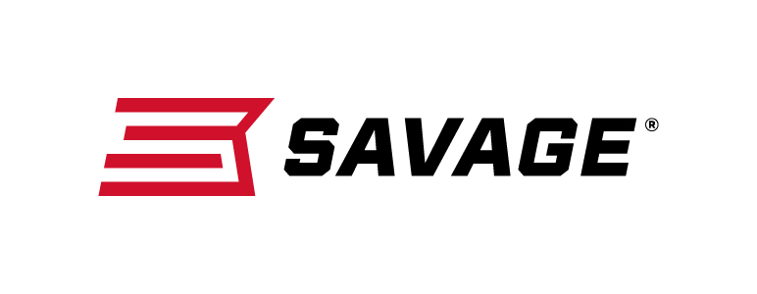
FOR IMMEDIATE RELEASE

Savage Unveils the Complete Package: 110 APEX Hunter XP

Westfield, Massachusetts – April 15, 2019 – Savage is proud to introduce the 110 Apex Hunter XP, which pairs a Model 110 rifle with a 3-9x40mm Vortex Crossfire II scope that comes mounted, bore-sighted and ready to hunt. Shipments of these firearms have been delivered to dealers.

The platform provides accuracy and adjustability like no other package rifle thanks to the Savage AccuTrigger, thread- in headspacing, floating bolt head and precision button-rifled barrel. Plus, its length-of-pull can be quickly adjusted to fit any hunter for better comfort and consistency. The Crossfire II Dead-Hold BDC reticle makes it easier to place accurate shots at extended range, and the optic is securely mounted to a one-piece EGW 0 MOA rail.

Features
- Redesigned Model 110 rifle
- 3-9x40mm Vortex Crossfire II scope, mounted and bore-sighted
- Dead-Hold BDC reticle’s hashmark design reduces guesswork on holdover and windage
- Vortex Hunter medium rings and one-piece EGW 0 MOA rail
- User-adjustable AccuTrigger
- Adjustable length-of-pull
- Modern ergonomics
- Detachable box magazine
- Available in left hand models and with Muddy Girl stock

The available model list below also includes the 110 APEX Hunter XP in left-hand and Muddy Girl Camo options, plus the 110 APEX Storm XP which is the stainless steel receiver and barrel option.

Part No. / Description / MSRP
57301 / 110 APEX Hunter XP 204 Ruger, 20-inch barrel / $684
57300 / 110 APEX Hunter XP 223 Rem., 20-inch barrel / $684
57302 / 110 APEX Hunter XP 22-250 Rem., 20-inch barrel / $684
57303 / 110 APEX Hunter XP 243 Win., 22-inch barrel / $684
57310 / 110 APEX Hunter XP 25-06 Rem., 24-inch barrel / $684
57304 / 110 APEX Hunter XP 6.5 Creedmoor, 24-inch barrel / $684
57311 / 110 APEX Hunter XP 6.5X284 Norma, 24-inch barrel / $684
57306 / 110 APEX Hunter XP 260 Rem., 24-inch barrel / $684
57312 / 110 APEX Hunter XP 270 Win., 22-inch barrel / $684
57308 / 110 APEX Hunter XP 270 WSM, 24-inch barrel / $684
57305 / 110 APEX Hunter XP 7mm-08 Rem., 20-inch barrel / $684
57314 / 110 APEX Hunter XP 7mm Rem. Mag., 24-inch barrel / $684
57307 / 110 APEX Hunter XP 308 Win., 20-inch barrel / $684
57313 / 110 APEX Hunter XP 30-06 Sprg., 22-inch barrel / $684
57309 / 110 APEX Hunter XP 300 WSM, 24-inch barrel / $684
57315 / 110 APEX Hunter XP 300 Win. Mag., 24-inch barrel / $684
57316 / 110 APEX Hunter XP 338 Win. Mag., 24-inch barrel / $684
57317 / 110 APEX Hunter XP (LH) 223 Rem., 20-inch barrel / $684
57318 / 110 APEX Hunter XP (LH) 22-250 Rem., 20-inch barrel / $684
57319 / 110 APEX Hunter XP (LH) 243 Win., 22-inch barrel / $684
57323 / 110 APEX Hunter XP (LH) 25-06 Rem., 24-inch barrel / $684
57320 / 110 APEX Hunter XP (LH) 6.5 Creedmoor, 24-inch barrel / $684
57324 / 110 APEX Hunter XP (LH) 270 Win., 22-inch barrel / $684
57321 / 110 APEX Hunter XP (LH) 7mm-08 Rem., 20-inch barrel / $684
57326 / 110 APEX Hunter XP (LH) 7mm Rem. Mag., 24-inch barrel / $684
57322 / 110 APEX Hunter XP (LH) 308 Win., 20-inch barrel / $684
57325 / 110 APEX Hunter XP (LH) 30-06 Sprg., 22-inch barrel / $684
57327 / 110 APEX Hunter XP (LH) 300 Win. Mag., 24-inch barrel / $684
57336 / 110 APEX Hunter XP Muddy Girl 243 Win., 22-inch barrel / $729
57337 / 110 APEX Hunter XP Muddy Girl 6.5 Creedmoor, 24-inch barrel / $729
57338 / 110 APEX Hunter XP Muddy Girl 7mm-08 Rem., 20-inch barrel / $729
57339 / 110 APEX Hunter XP Muddy Girl 308 Win., 20-inch barrel / $729
57341 / 110 APEX Storm XP 204 Ruger, 20-inch barrel / $739
57340 / 110 APEX Storm XP 223 Rem., 20-inch barrel / $739
57342 / 110 APEX Storm XP 22-250 Rem., 20-inch barrel / $739
57343 / 110 APEX Storm XP 243 Win., 22-inch barrel / $739
57350 / 110 APEX Storm XP 25-06 Rem., 24-inch barrel / $739
57344 / 110 APEX Storm XP 6.5 Creedmoor, 24-inch barrel / $739
57346 / 110 APEX Storm XP 260 Rem., 24-inch barrel / $739
57351 / 110 APEX Storm XP 270 Win., 22-inch barrel / $739
57348 / 110 APEX Storm XP 270 WSM, 24-inch barrel / $739
57345 / 110 APEX Storm XP 7mm-08 Rem., 20-inch barrel / $739
57353 / 110 APEX Storm XP 7mm Rem. Mag., 24-inch barrel / $739
57347 / 110 APEX Storm XP 308 Win., 20-inch barrel / $739
57352 / 110 APEX Storm XP 30-06 Sprg., 22-inch barrel / $739
57349 / 110 APEX Storm XP 300 WSM, 24-inch barrel / $739
57354 / 110 APEX Storm XP 300 Win. Mag., 24-inch barrel / $739
57355 / 110 APEX Storm XP 338 Win. Mag., 24-inch barrel / $739
Learn more about Savage. Visit www.savagearms.com.

Press Release Contact: JJ Reich
Senior Communications Manager - Firearms and Ammunition
E-mail: VistaPressroom@VistaOutdoor.com

About Savage
Headquartered in Westfield, Massachusetts for 125 years, Savage is one of the world's largest manufacturers of hunting, competition and self-defense centerfire and rimfire rifles, and shotguns. Their firearms are best known for accuracy and value. The entrepreneurial spirit that originally defined the company is still evident in its ongoing focus on continuous innovations, craftsmanship, quality and service. Learn more at www.savagearms.com.

###

