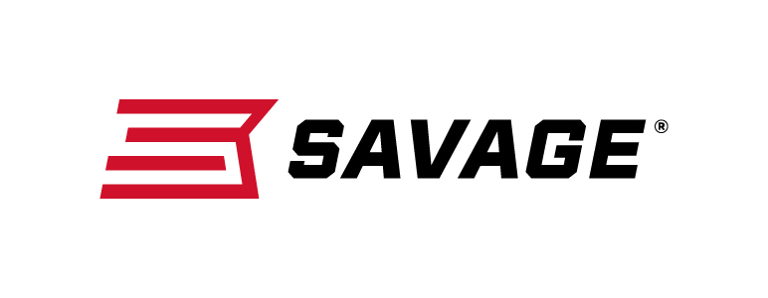
FOR IMMEDIATE RELEASE

Savage’s AXIS II Combines High-End Features with Friendly Price

Westfield, Massachusetts – March 5, 2019 – Savage brings together precision, performance and price with its new AXIS II rifle which features an AccuTrigger and updated stock. Shipments of these firearms have been delivered to dealers.

Savage rebuilt the synthetic stock on the AXIS II for improved ergonomics that let any hunter shoot their best. Like always, the rifle’s user-adjustable AccuTrigger, thread-in headspacing and floating bolt head extract the utmost accuracy from the 22-inch button rifled sporter barrel for the performance of high-end hunting rifles at a fraction of the price.

Features
- Improved ergonomics and rugged synthetic stock
- User-adjustable AccuTrigger
- Carbon steel button-rifled sporter barrel
- Detachable box magazine
- Thread-in barrel headspacing

Part No. / Description / MSRP
57365 / AXIS II 223 Rem., 22-inch barrel / $429
57366 / AXIS II 22-250 Rem., 22-inch barrel / $429
57367 / AXIS II 243 Win., 22-inch barrel / $429
57371 / AXIS II 25-06 Rem., 22-inch barrel / $429
57368/ AXIS II 6.5 Creedmoor, 22-inch barrel / $429
57372 / AXIS II 270 Win., 22-inch barrel / $429
57369 / AXIS II 7mm-08, 22-inch barrel / $429
57374 / AXIS II 280 Ackley Improved, 22-inch barrel / $429
57370 / AXIS II 308 Win., 22-inch barrel / $429
57373 / AXIS II 30-06 Sprg., 22-inch barrel / $429
57384/ AXIS Compact 223 Rem., 20-inch barrel / $429
57385 / AXIS Compact 243 Win., 20-inch barrel / $429
57386 / AXIS Compact 6.5 Creedmoor, 20-inch barrel / $429
57387 / AXIS Compact 7mm-08 Rem., 20-inch barrel / $429
Learn more about Savage. Visit www.savagearms.com.

Press Release Contact: JJ Reich
Senior Communications Manager - Firearms and Ammunition
E-mail: VistaPressroom@VistaOutdoor.com

About Savage
Headquartered in Westfield, Massachusetts for more than 100 years, Savage is one of the world's largest manufacturers of hunting, competition and self-defense centerfire and rimfire rifles, and shotguns. Their firearms are best known for accuracy and value. The entrepreneurial spirit that originally defined the company is still evident in its ongoing focus on continuous innovations, craftsmanship, quality and service. Learn more at www.savagearms.com.

###

