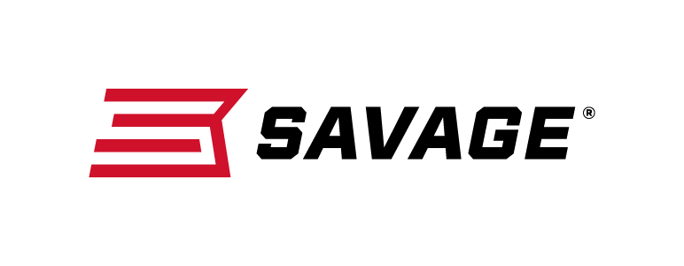
FOR IMMEDIATE RELEASE

New Savage 110 High Country Ideal for Western Hunting and
Long-Distance Shooting

Westfield, Massachusetts – June 12, 2019 – Savage is excited to unveil the 110 High Country, a rifle that gives Western hunters the precision and power to take the biggest bulls and the longest shots. Shipments of these firearms have been delivered to dealers.

The 110 High Country is built to maximize accuracy with a spiral-fluted barrel and bolt, as well as the Model 110 action secured three-dimensionally along its entire length within the AccuStock internal chassis. The AccuFit system lets hunters customize length-of-pull and comb height of the TrueTimber Strata synthetic stock. Plus, the user-adjustable AccuTrigger offers a crisp, clean pull critical for making precise shots at extreme distances. The low-friction, coyote brown PVD coating on the barrel, receiver and other critical parts is harder than competing finishes and protects against corrosion and heat. At just 2-4 microns thick, the coating does not interfere with the rifle’s tight tolerances.

Features
- AccuFit system lets hunters adjust comb height and length-of-pull
- User-adjustable AccuTrigger
- AccuStock rail system
- TrueTimber Strata synthetic stock with overmold surfaces
- Model 110 stainless steel barreled action with coyote brown PVD coating
- Spiral-fluted barrel and bolt
- Threaded muzzle; magnum calibers feature muzzle brake with taperlock interface
- Detachable box magazine
- PVD-coated bolt handle, receiver, barrel, trigger guard and magwell
- Drilled and tapped receiver
- Three-position safety

Part No. / Description / MSRP
57411 / 110 High Country 243 Win., 22-inch barrel / $1,129
57412 / 110 High Country 6.5 Creedmoor, 22-inch barrel / $1,129
57419 / 110 High Country 6.5 PRC, 24-inch barrel / $1,129
57413 / 110 High Country 270 Win., 22-inch barrel / $1,129
57417 / 110 High Country 280 Ackley Imp., 22-inch barrel / $1,129
57415 / 110 High Country 7mm-08 Rem., 22-inch barrel / $1,129
57418 / 110 High Country 7mm Rem. Mag., 24-inch barrel / $1,129
57410 / 110 High Country 308 Win., 22-inch barrel / $1,129
57414 / 110 High Country 30-06 Sprg., 22-inch barrel / $1,129
57420 / 110 High Country 300 Win. Mag., 24-inch barrel / $1,129
57416 / 110 High Country 300 WSM, 24-inch barrel / $1,129
Learn more about Savage. Visit www.savagearms.com.

Press Release Contact: JJ Reich
Senior Communications Manager - Firearms and Ammunition
E-mail: VistaPressroom@VistaOutdoor.com

About Savage
Headquartered in Westfield, Massachusetts for 125 years, Savage is one of the world's largest manufacturers of hunting, competition and self-defense centerfire and rimfire rifles, and shotguns. Their firearms are best known for accuracy and value. The entrepreneurial spirit that originally defined the company is still evident in its ongoing focus on continuous innovations, craftsmanship, quality and service. Learn more at www.savagearms.com.

