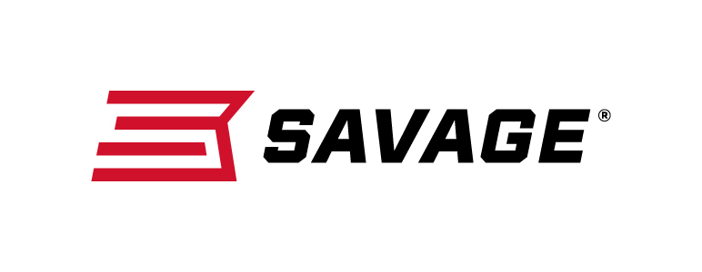
FOR IMMEDIATE RELEASE

Savage Redesigns AXIS with New Performance Features

Westfield, Massachusetts – February 19, 2019 – Savage’s groundbreaking AXIS rifle has a new look and design for better performance. Shipments of these firearms have been delivered to dealers.

When the AXIS was introduced, it totally changed what hunters should expect from an entry-level rifle. The redesigned AXIS is even better. In addition to a fresh look with improved ergonomics, it’s loaded with features that deliver Savage’s legendary accuracy, including thread-in headspacing, button rifling and a floating bolt head. The AXIS is offered in the complete spectrum of popular hunting calibers, in full-size, compact and left-hand models.

Features
- Rugged synthetic stock with new ergonomic design
- Sporter barrel contour
- Carbon steel barreled action with matte black finish
- Detachable box magazine
- Also available in left hand and compact models
- Weaver-style two-piece bases
- Recoil pad

The available model list below also includes the AXIS left-hand and compact stock options.

Part No. / Description / MSRP
57233 / AXIS 223 Rem., 22-inch barrel / $375
57234 / AXIS 22-250 Rem., 22-inch barrel / $375
57235 / AXIS 243 Win., 22-inch barrel / $375
57239 / AXIS 25-06 Rem., 22-inch barrel / $375
57236 / AXIS 6.5 Creedmoor, 22-inch barrel / $375
57240 / AXIS 270 Win., 22-inch barrel / $375
57237 / AXIS 7mm-08 Rem., 22-inch barrel / $375
57238 / AXIS 308 Win., 22-inch barrel / $375
57241 / AXIS 30-06 Sprg., 22-inch barrel / $375
57247 / AXIS Left-Hand 223 Rem., 22-inch barrel / $375
57248 / AXIS Left-Hand 22-250 Rem., 22-inch barrel / $375
57249 / AXIS Left-Hand 243 Win., 22-inch barrel / $375
57253 / AXIS Left-Hand 25-06 Rem., 22-inch barrel / $375
57250 / AXIS Left-Hand 6.5 Creedmoor, 22-inch barrel / $375
57254 / AXIS Left-Hand 270 Win., 22-inch barrel / $375
57251 / AXIS Left-Hand 7mm-08 Rem., 22-inch barrel / $375
57252 / AXIS Left-Hand 308 Win., 22-inch barrel / $375
57255 / AXIS Left-Hand 30-06 Sprg., 22-inch barrel / $375
57244 / AXIS Compact 223 Rem., 20-inch barrel / $375
57245 / AXIS Compact 243 Win., 20-inch barrel / $375
57246 / AXIS Compact 7mm-08 Rem., 20-inch barrel / $375
57242 / AXIS Compact Left-Hand 243 Win., 20-inch barrel / $375
57243 / AXIS Compact Left-Hand 7mm-08, 20-inch barrel / $375

Learn more about Savage. Visit www.savagearms.com.

Press Release Contact: JJ Reich
Senior Communications Manager - Firearms and Ammunition
E-mail: VistaPressroom@VistaOutdoor.com

About Savage
Headquartered in Westfield, Massachusetts for more than 100 years, Savage is one of the world's largest manufacturers of hunting, competition and self-defense centerfire and rimfire rifles, and shotguns. Their firearms are best known for accuracy and value. The entrepreneurial spirit that originally defined the company is still evident in its ongoing focus on continuous innovations, craftsmanship, quality and service. Learn more at www.savagearms.com.

###

