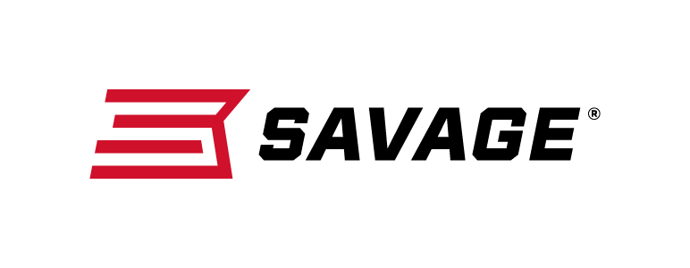
FOR IMMEDIATE RELEASE

Savage’s New 110 Apex Predator XP Perfect for Crushing Carnivores

Westfield, Massachusetts – June 4, 2019 – Savage is excited to announce the new 110 Apex Predator XP, which offers adjustability and accuracy like no other predator package rifle. Shipments of these firearms have been delivered to dealers.

The 110 Apex Predator XP pairs a Model 110 rifle with a 4-12x44mm Vortex Crossfire II scope that comes mounted, bore-sighted and ready to hunt. The gun features the Savage AccuTrigger, thread-in heasdpacing, floating bolt head and precision button-rifled heavy barrel. Plus, the length-of-pull of its synthetic Mossy Oak camo stock can be quickly adjusted to fit any hunter for better comfort and consistency. The Crossfire II’s Dead-Hold BDC reticle makes it easier to place accurate shots at extended range, and the optic is securely mounted to a one-piece EGW 0 MOA rail.

Features
- Redesigned Model 110 rifle
- Carbon steel heavy barrel threaded with protector
- Mossy Oak Terra synthetic stock
- 4-12x44mm Vortex Crossfire II scope, mounted and bore-sighted
- Dead-Hold BDC reticle’s hashmark design reduces guesswork on holdover and windage
- Vortex Hunter medium rings and one-piece EGW 0 MOA rail
- User-adjustable AccuTrigger
- Adjustable length-of-pull
- Modern ergonomics
- Detachable box magazine

Part No. / Description / MSRP
57358 / 110 Apex Predator XP 204 Ruger, 20-inch barrel / $739
57356 / 110 Apex Predator XP 223 Rem., 20-inch barrel / $739
57357 / 110 Apex Predator XP 22-250 Rem., 20-inch barrel / $739
57359 / 110 Apex Predator XP 243 Win., 24-inch barrel / $739
57360 / 110 Apex Predator XP 6.5 Creedmoor, 24-inch barrel / $739
57361 / 110 Apex Predator XP 308 Win., 20-inch barrel / $739
Learn more about Savage. Visit www.savagearms.com.

Press Release Contact: JJ Reich
Senior Communications Manager - Firearms and Ammunition
E-mail: VistaPressroom@VistaOutdoor.com

About Savage
Headquartered in Westfield, Massachusetts for more than 100 years, Savage is one of the world's largest manufacturers of hunting, competition and self-defense centerfire and rimfire rifles, and shotguns. Their firearms are best known for accuracy and value. The entrepreneurial spirit that originally defined the company is still evident in its ongoing focus on continuous innovations, craftsmanship, quality and service. Learn more at www.savagearms.com.

###

