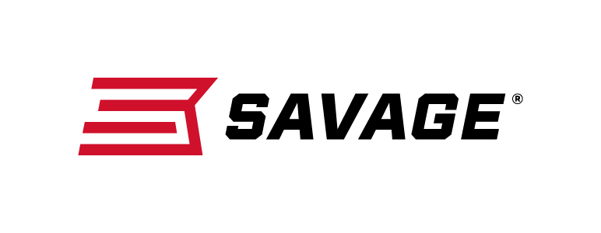
FOR IMMEDIATE RELEASE

Savage Expands AccuFit Family of Rifles in 2019

New Savage AccuFit Guns Cater to Turkey Hunters, Western Shooters

Westfield, Massachusetts – January 15, 2019 – Savage continues to expand its line of purpose-built AccuFit bolt-action firearms with new models for Western hunters and turkey die-hards. Savage will have these new firearms on display in Booth No. 14551 at the 2019 SHOT Show, January 22-25 at the Sands Expo Center in Las Vegas, Nevada.

Savage’s revolutionary patented AccuFit system lets shooters customize their firearm’s comb height and length of pull for a perfect fit—something not found on other guns.

“We started thinking a lot more about the individual shooter — what their unique needs are and what drives them to ultimately go to a gunsmith,” said Savage Senior Marketing Manager Beth Shimanski. “That’s when we decided to really raise the bar and make the gun fit better too, and the AccuFit system was born.”

For 2019, Savage has unveiled the 110 High Country centerfire rifle, and 212 and 220 bolt-action turkey shotguns. Purpose-built for the back country or back woods, Savage’s new AccuFit firearms continue to deliver a long list of premium features at affordable prices.

Western big game hunters will appreciate the long list of standard features on the new 110 High Country rifle. This long-range rifle is built to minimize weight and maximize accuracy with a spiral-fluted barrel and bolt, as well as the Model 110 action secured three-dimensionally along its entire length within the AccuStock internal chassis.

Like other 110 rifles the High Country features a floating bolt head and a barrel nut that ensures reliable and consistent headspacing for unmatched accuracy. The AccuFit system lets hunters customize length- of-pull and comb height of the TrueTimber Strata synthetic stock.

The Savage Model 212 (12-gauge) and 220 (20-gauge) bolt-action turkey shotguns are built around the Model 110 rifle action, which is machined from billet steel bar stock and secured three-dimensionally along its entire length by the AccuStock internal chassis. Their blued, 22-inch carbon steel, smoothbore barrels are free-floating and secured
to the receiver using a Model 110-style locking nut that ensures shot-to-shot consistency.

A user-adjustable AccuTrigger provides a light, crisp pull, and the AccuFit system allows hunters to customize length-of- pull and comb height for precision you won’t find in any other turkey gun.

Learn more about Savage. Visit www.savagearms.com.

Press Release Contact: JJ Reich
Senior Communications Manager - Firearms and Ammunition
E-mail: VistaPressroom@VistaOutdoor.com

About Savage
Headquartered in Westfield, Massachusetts for more than 100 years, Savage is one of the world's largest manufacturers of hunting, competition and self-defense centerfire and rimfire rifles, and shotguns. Their firearms are best known for accuracy and value. The entrepreneurial spirit that originally defined the company is still evident in its ongoing focus on continuous innovations, craftsmanship, quality and service. Learn more at www.savagearms.com.

###

