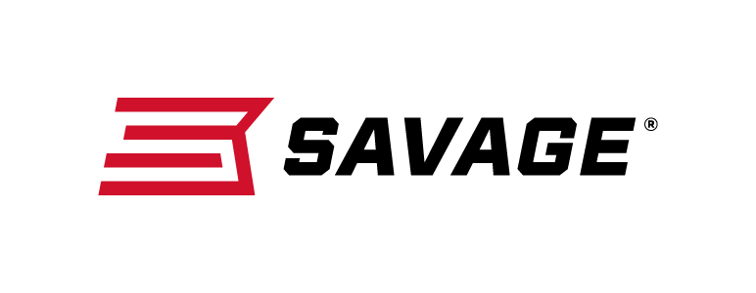
FOR IMMEDIATE RELEASE

Savage Delivers the Perfect Package

Savage Package Guns Combine Value and Performance

Westfield, Massachusetts – January 14, 2019 – Savage has expanded and upgraded its lineup of XP package guns, making it easier than ever for hunters to take a rifle from the box to their blind. Savage will have these new firearms on display in Booth No. 14551 at the 2019 SHOT Show, January 22-25 at the Sands Expo Center in Las Vegas, Nevada.

XP package guns fit new rifles with appropriate scopes that are perfectly matched for that rifle. Savage mounts these scopes with the correct scope mounts and rings as well as bore-sights the rifle for ease of zeroing in for the end user, saving time and valuable ammunition. Furthermore, buying a pre-assembled and bore-sighted Savage XP package gun is often less costly than buying the same components separately, making them one of the best bargains in firearms.

“We’re working to provide the most convenient, simple, reliable and trusted rifle options available anywhere,” said Al Kasper, president of Savage. “Our easy-to-use XP package guns offer the absolute best value for shooters and hunters.”
In 2018, Savage offered 62 different XP package gun models. It has added to that extensive line in 2019. There’s a Savage XP combo that’s sure to work well for any shooter, regardless of the target, the terrain or budget.

The new 110 Apex Predator XP comes equipped with a Vortex Crossfire II 4-12x44mm scope with Dead-Hold BDC reticle, a heavy threaded barrel and Mossy Oak camo stock.

The new 110 Apex Hunter XP comes with a black synthetic stock, sporter barrel, and a 3-9x40mm Vortex Crossfire II scope with Dead-Hold BDC reticle found on the Apex Predator XP. The 110 Apex Hunter XP package is available in left- and right-handed versions as well as a Muddy Girl camo version with several caliber options.

The new 110 Apex Storm XP also comes with a 3-9x40mm Vortex scope with Dead-Hold reticle. It features stainless steel metalwork for hunting in the most unforgiving conditions.

Also for 2019, all AXIS XP package guns have been upgraded with the newly re- designed, stylish, ergonomic synthetic stock. The AXIS XP and AXIS Camo XP versions are available with compact stocks. There’s also an AXIS XP Camo Compact Muddy Girl camo version available. AXIS XP rifles come equipped with 3-9x40mm Weaver scopes mounted and bore-sighted.

“Last year, we upgraded the AXIS II XP product line, which are models that include the AccuTrigger, by changing to an improved, more rigid stock,” Kasper said. “It was a success, as we received many outstanding responses from our dealers and customers. This year, we are answering their requests to also upgrade the base-model AXIS firearm lineup with that same stylish and ergonomic stock.”
Learn more about Savage. Visit www.savagearms.com.

Press Release Contact: JJ Reich
Senior Communications Manager - Firearms and Ammunition
E-mail: VistaPressroom@VistaOutdoor.com

About Savage
Headquartered in Westfield, Massachusetts for more than 100 years, Savage is one of the world's largest manufacturers of hunting, competition and self-defense centerfire and rimfire rifles, and shotguns. Their firearms are best known for accuracy and value. The entrepreneurial spirit that originally defined the company is still evident in its ongoing focus on continuous innovations, craftsmanship, quality and service. Learn more at www.savagearms.com.

###

