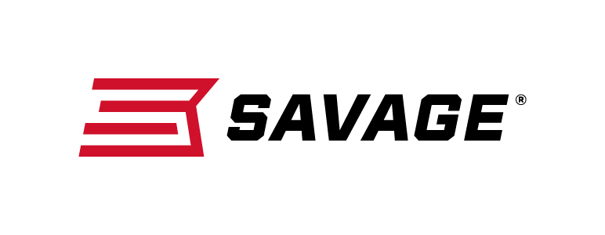

FOR IMMEDIATE RELEASE

Savage Will Launch 40 New Products at the 2019 SHOT Show

Westfield, Massachusetts – January 8, 2019 – Savage will launch more than three dozen new products within several product lines at the 2019 SHOT Show, January 22-25 at the Sands Expo Center in Las Vegas, Nevada.

“Savage is one of the world’s largest manufacturers of rifles and shotguns dedicated to hunting, competition, defense and having fun at the range,” said Beth Shimanski, Director of Marketing for Savage. “It’s another huge year for Savage. We are excited to deliver another year of innovative firearms in many caliber and gauge options. Whether you are looking for a training rifle for young shooters, a competition-grade modern sporting rifle, a reliable shotgun for hunting or personal defense or a lightweight hunting rifle packaged with a scope: Savage has those needs covered, plus more.”

New 2019 Product Launch Highlights:

2019 marks Savage’s 125th anniversary. The brand is celebrating the historic event by offering limited-edition rifles.

The company is expanding and improving our popular XP scoped rifle lines. New models include the 110 Apex XP series, featuring Vortex scopes, and a pint-sized Rascal Target XP. Plus, the existing AXIS XP series has been upgraded with a new modernized stock.

Savage’s game-changing AccuFit system lets shooters quickly adjust comb height and length-of-pull. The feature is an integral part of a new long-range rifle with a superior finish, the 110 High Country, as well as two new bolt-action turkey shotguns.

The company has added to the lineup of AXIS and AXIS II rifles sold as standard base models so hunters can purchase their optics of choice. All have redesigned stocks with new looks and improved ergonomics.

Savage’s next-generation MSR 15 and MSR 10 rifle lines continue to expand with new options built for long-range, precision and competition shooting. All deliver accuracy, performance and a full suite of custom upgrades packaged as standard features.

Stevens 320 Security and Field Grade pump-action shotguns have received major stock upgrades that improve the reliable platform’s look and feel.

Savage will also introduce a new specialized single-shot turkey gun designed for Federal’s.410 HEAVYWEIGHT TSS turkey loads, as well as a 16-gauge 555 Enhanced over-and-under—the latest in the lineup of sub-gauge options.

All of these new rifles, as well as more bolt-action and semi-automatic centerfire and rimfire rifles, will be on display at Booth No. 14551 for customers to view and learn product details.

Learn more about Savage, visit www.savagearms.com.

Press Release Contact: JJ Reich
Senior Communications Manager - Firearms and Ammunition
E-mail: VistaPressroom@VistaOutdoor.com

About Savage
Headquartered in Westfield, Massachusetts for more than 100 years, Savage is one of the world's largest manufacturers of hunting, competition and self-defense centerfire and rimfire rifles, and shotguns. Their firearms are best known for accuracy and value. The entrepreneurial spirit that originally defined the company is still evident in its ongoing focus on continuous innovations, craftsmanship, quality and service.

###

