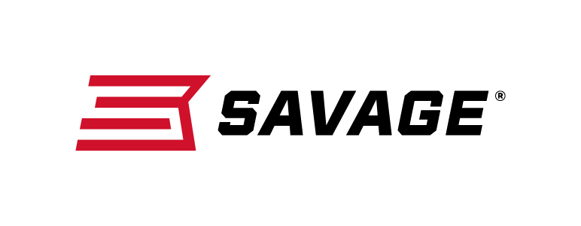
FOR IMMEDIATE RELEASE

Savage Launches Several More New Guns for 2019

Westfield, Massachusetts – February 13, 2019 – Savage is excited to have introduced more than 40 new firearms at the 2019 Shooting, Hunting and Outdoor Trade (SHOT) Show, held Jan. 22 through 26 in Las Vegas, Nevada. During the show, the company announced several additional firearms not mentioned prior to the show in marketing materials or its product catalog. These include the new Model 64 Takedown, 110 Prairie Hunter bolt-action 224 Valkyrie and four new left-hand models in the company’s pint-size rimfire Rascal family.

The Model 64 Takedown 22 LR rimfire rifle combines the accuracy and dependability of the original Model 64 semi-automatic platform with an easy takedown design, compact 16 1⁄2-inch barrel and Uncle Mike’s Bug-Out Bag. It puts rounds downrange and on target fast using a consistent straight-blowback action fed by a detachable 10-round box magazine.

The 110 Prairie Hunter unleashes the full power and accuracy of 224 Valkyrie on varmints and predators. Its AccuFit system makes it easy to customize comb height and length-of-pull to any hunter. Combined with its user-adjustable AccuTrigger, 22-inch button-rifled barrel and target crown, the rifle delivers the most consistent accuracy at extreme ranges.

Savage’s four new models of synthetic-stock, left-hand Rascals expand the industry’s safest micro-rimfire rifle line. Shooters cock the rifle by lifting the bolt and unload without pulling the trigger. It features adjustable peep sights and Savage’s user-adjustable AccuTrigger.

Go to www.savagearms.com for full product details.

Part No. / Description / MSRP
40207 / Model 64 Takedown Right-Hand, 16.5-inch barrel / $249
40210 / Model 64 Takedown Left-Hand, 16.5-inch barrel / $249
57409 / Model 110 Prairie Hunter, 22-inch barrel / $759
13843 / Rascal Left-Hand Black Synthetic 22 S, L, LR; 16.125-inch barrel / $191
13844 / Rascal Left-Hand Pink Synthetic 22 S, L, LR; 16.125-inch barrel / $191
13841 / Rascal FLV-SR Black 22 S, L, LR; 16.125-inch barrel / $219
13842 / Rascal FLV-SR Pink 22 S, L, LR; 16.125-inch barrel / $219
Learn more about Savage—visit www.savagearms.com.

Press Release Contact: JJ Reich
Senior Communications Manager - Firearms and Ammunition
E-mail: VistaPressroom@VistaOutdoor.com

About Savage
Headquartered in Westfield, Massachusetts for more than 100 years, Savage is one of the world's largest manufacturers of hunting, competition and self-defense centerfire and rimfire rifles, and shotguns. Their firearms are best known for accuracy and value. The entrepreneurial spirit that originally defined the company is still evident in its ongoing focus on continuous innovations, craftsmanship, quality and service. Learn more at www.savagearms.com.

###

