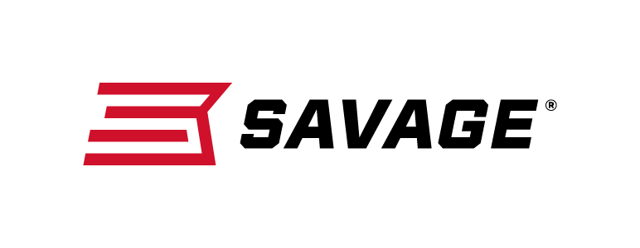
FOR IMMEDIATE RELEASE

Savage’s New Model 64 Takedown is Accurate, Dependable and Easy to Use

Westfield, Massachusetts – March 27, 2019 – Savage’s new Model 64 Takedown offers great performance and ease of use. The new rimfire rifle is quick to breakdown and ready to go. Shipments of these firearms have been delivered to dealers.

This easy-to-use 22 LR combines the accuracy and dependability of the original Model 64 semi-automatic platform with an easy takedown design, compact 16 1⁄2-inch barrel and Uncle Mike’s Bug-Out Bag. It puts rounds downrange and on target fast using a consistent straight-blowback action fed by a detachable 10-round box magazine.

Features
- Reliable, semi-automatic takedown 22 LR
- 16 1⁄2-inch matte black carbon steel barrel
- Barrel nut allows easy disassembly
- Includes Uncle Mike’s Bug-Out Bag
- 10-round detachable box magazine
- Black matte synthetic stock
- Drilled and tapped receiver for scope mounts
- Available in right- and left-hand models

Part No. / Description / MSRP
40207 / Model 64 Takedown Right-Hand, 16.5-inch barrel / $249
40210 / Model 64 Takedown Left-Hand, 16.5-inch barrel / $249
Learn more about Savage—visit www.savagearms.com.

Press Release Contact: JJ Reich
Senior Communications Manager - Firearms and Ammunition
E-mail: VistaPressroom@VistaOutdoor.com
About Savage
Headquartered in Westfield, Massachusetts for more than 100 years, Savage is one of the world's largest manufacturers of hunting, competition and self-defense centerfire and rimfire rifles, and shotguns. Their firearms are best known for accuracy and value. The entrepreneurial spirit that originally defined the company is still evident in its ongoing focus on continuous innovations, craftsmanship, quality and service. Learn more at www.savagearms.com.

###

