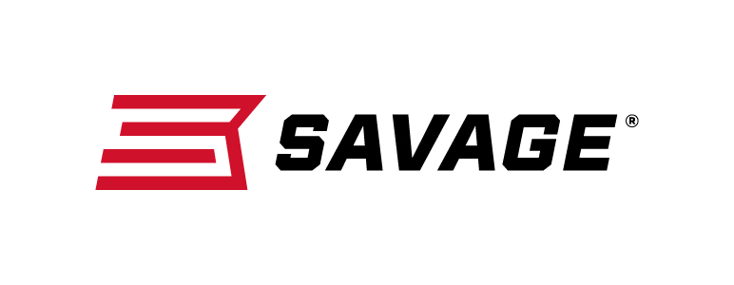
FOR IMMEDIATE RELEASE

Savage Launches Several Great Firearms Featuring NRA’s Official Camouflage Pattern: Mossy Oak Overwatch

Westfield, Massachusetts – April 22, 2019 – Savage is excited to announce a lineup of new firearms in NRA’s Mossy Oak Overwatch camouflage at the 2019 NRA Meetings & Exhibits Show in Indianapolis, Indiana, April 26-28, 2019. Attendees are invited to visit the Vista Outdoor booth 4955 during the show to see and learn more about these new firearms, which will be available at dealers this summer. Mossy Oak will also be giving away nine Savage AXIS II Overwatch rifles at its booth, 4404, during the three-day show.

Mossy Oak recently became the National Rifle Association’s Official Camouflage Partner. As a result, Mossy Oak developed an all-new pattern exclusive to the NRA: Overwatch. The unique pattern utilizes cutting-edge design technology and features the NRA logo embedded within the pattern. Wearing it helps NRA members show their support and passion for their American right to keep and bear arms, and the protection of America’s hunting, fishing and outdoors heritage.

Savage then partnered with Mossy Oak to create several firearms with the pattern. Overwatch firearm models include A22 FV-SR semi-auto in 22 LR, B Series bolt action in 22 LR and 17 HMR, A17 semi-auto in 17 HMR, MSR 15 Recon 2.0 semi-auto in 5.56x45mm/223 Rem., MSR 10 Hunter semi-auto in .308 Win. and 6.5 Creedmoor, Model 110 Ridge Warrior bolt-action in 308 Win. and 6.5 Creedmoor, and AXIS II bolt-action in many caliber options.

Savage Arms and Mossy Oak are teaming up to give away nine AXIS II Overwatch rifles during the NRA Annual Meetings & Exhibits. To enter, event attendees must visit the Mossy Oak booth, where instructions will be provided to enter. Three rifles will be given away per day. Entries must be submitted on-site, but contestants do not have to be present to win. Limit of one entry per person.

New Overwatch firearms and much more from Savage can be viewed at the Vista Outdoor booth during the NRA Annual Meetings & Exhibits. To learn more about Savage, visit www.savagearms.com.

Press Release Contact: JJ Reich
Senior Communications Manager - Firearms and Ammunition
E-mail: VistaPressroom@VistaOutdoor.com

About Savage
Headquartered in Westfield, Massachusetts for 125 years, Savage is one of the world's largest manufacturers of hunting, competition and self-defense centerfire and rimfire rifles, and shotguns. Their firearms are best known for accuracy and value. The entrepreneurial spirit that originally defined the company is still evident in its ongoing focus on continuous innovations, craftsmanship, quality and service. Learn more at www.savagearms.com.

###

