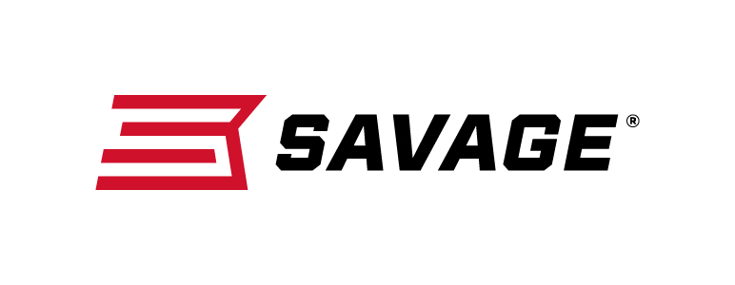
FOR IMMEDIATE RELEASE

Savage to Introduce More Than 12 New Guns at the
2019 NRA Annual Meetings & Exhibits

Westfield, Massachusetts – April 24, 2019 – Savage will announce more than a dozen new rifle configurations at the 2019 NRA Meetings & Exhibits in Indianapolis, Indiana, April 26-28. These new firearms will be available at dealers this summer. Savage invites attendees to visit booth 4955 during the show to see these new products and more.

The introductions include several great caliber additions and model upgrades to Savage’s existing centerfire and rimfire product lines. In addition, the company is poised to release a full lineup of firearms in new Mossy Oak Overwatch, the official camouflage pattern of the NRA.

For starters, Savage has expanded its Apex Hunter XP and Engage Hunter XP package rifles series to include 450 Bushmaster. The Apex Hunter XP comes with a Vortex Crossfire II 3-9x40mm scope and a one-piece rail, while the Engage Hunter XP features a Bushnell Engage 3-9x40mm. Both scopes are mounted, bore-sighted and ready to shoot.

The new 110 Classic features a quality walnut stock with modern ergonomics similar to those of the new Model 110 design. The stock’s length-of-pull and comb height adjust in quarter-inch increments to allow peak comfort, consistency and precision for any shooter. The 110 Classic is available in eight popular chamberings.

Savage has also expanded the A17 line with a chambering for 17 Mach 2, another flat-shooting, high-velocity rimfire cartridge. Its unique delayed-blowback action provides safe, reliable operation with any 17 Mach 2 load.

The new A22 FV-SR semi- automatic 22 LR upgrades the original A22 platform with a button-rifled, medium-contour barrel and threaded muzzle. It features a gray synthetic stock, user-adjustable AccuTrigger and reliable straight blowback action. This rifle is complete with a matte black finish, a new feature for this product line.

Savage has expanded the AXIS II line to include a chambering for 300 Blackout, providing the ballistics that made the cartridge famous—now in a bolt-action platform built for hunters. Savage also expanded the 110 Tactical lineup to include left-hand models, a 6.5 PRC chambering, and other options.

Finally, Savage has partnered with Mossy Oak to create several firearms with new Overwatch camo. Models include A22 FV-SR semi-auto in 22 LR, B Series bolt action in 22 LR and 17 HMR, A17 semi-auto in 17 HMR, MSR 15 Recon 2.0 semi-auto in 5.56x45mm /223 Rem., MSR 10 Hunter semi-auto in 308 Win. and 6.5 Creedmoor, Model 110 Ridge Warrior bolt-action in 308 Win. and 6.5 Creedmoor, and AXIS II bolt-action in many caliber options.
Mossy Oak Overwatch utilizes cutting-edge design technology and features the NRA logo embedded within the pattern. Wearing it helps NRA members show their support and passion for the right to keep and bear arms, and the protection of America’s hunting, fishing and outdoors heritage.

These products and many more from Savage can be viewed at booth 4955 during the NRA Annual Meetings & Exhibits. Learn more about Savage at www.savagearms.com.

Press Release Contact: JJ Reich
Senior Communications Manager - Firearms and Ammunition
E-mail: VistaPressroom@VistaOutdoor.com

About Savage
Headquartered in Westfield, Massachusetts for 125 years, Savage is one of the world's largest manufacturers of hunting, competition and self-defense centerfire and rimfire rifles, and shotguns. Their firearms are best known for accuracy and value. The entrepreneurial spirit that originally defined the company is still evident in its ongoing focus on continuous innovations, craftsmanship, quality and service. Learn more at www.savagearms.com.

###

