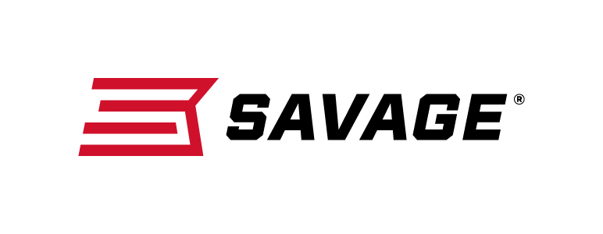
FOR IMMEDIATE RELEASE

PRS Titles Savage as its 2019 Official Gas Gun

Westfield, Massachusetts – February 20, 2019 –Savage Arms has been named the 2019 Official Gas Gun of the Precision Rifle Series.

“Savage Arms, an industry leader in out-of-the-box purpose-built firearms, has been an integral supporter of the PRS, its growth and our competitions,” said Shannon Kay, PRS director. “This year, Savage will now support the entire series and our members. We’d like to thank the entire team at Savage Arms for their unmatched professionalism and dedication to delivering products designed to give our shooters an edge.”

PRS is an annual points race for several series, including the PRS Bolt Gun Series, PRS Gas Gun Series and PRS Club Series. The matches involve the practical application of long-range rifle shooting born out of military, law-enforcement and hunting scenarios.

“Savage has a history of being extremely accurate straight from the factory,” said Beth Shimanski, marketing director for Savage. “We know that the PRS is all about accuracy, and we have focused our new product development to bring some products that pair perfectly with this discipline. This partnership is a great place for Savage to showcase these new products while supporting a great organization in our industry.”

Shimanski said Savage’s MSR 10 Precision will cover the PRS Open and Heavy Tactical divisions. The MSR 15 Long Range will compete in the Light Tactical division.

“Savage has always been known for building accurate, competition-ready rifles, as seen in both our F-Class and 3-Gun competition models,” she said. “With the growth of PRS, we saw an opportunity for our rifles to excel in these competitions. Our introduction of the MSR 10 Precision was a perfect entry into this sport and allowed us to put our flag in the ground as the premier, complete and ready-to-compete gas gun of PRS.”

Kay said the partnership represents an ideal synergy.

“Together with Savage Arms, the shooters and match directors, we will work to deliver a world-class Precision Rifle Series organization that promotes and grows the sport of competitive precision rifle shooting,” she said.

Shimanski said Savage is excited to start the first year as the Official Gas Gun of PRS and will look to grow its support with new products and partnership in coming years.

Learn more about Savage. Visit www.savagearms.com.

Press Release Contact: JJ Reich
Senior Communications Manager - Firearms and Ammunition
E-mail: VistaPressroom@VistaOutdoor.com

About Savage
Headquartered in Westfield, Massachusetts for 125 years, Savage is one of the world's largest manufacturers of hunting, competition and self-defense centerfire and rimfire rifles, and shotguns. Their firearms are best known for accuracy and value. The entrepreneurial spirit that originally defined the company is still evident in its ongoing focus on continuous innovations, craftsmanship, quality and service. Learn more at www.savagearms.com.

###

