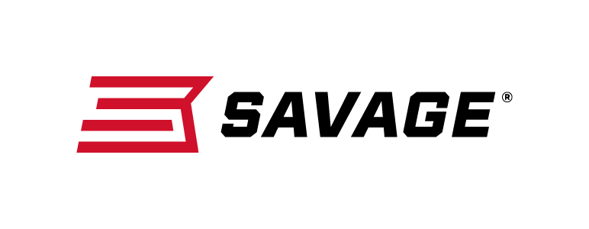
FOR IMMEDIATE RELEASE

Savage AXIS Package Rifles Combine Superb Performance with Factory-Mounted Optics

Westfield, Massachusetts – March 1, 2019 – Savage is proud to announce its lineup of redesigned AXIS XP rifles. These package firearms include bases, rings and a scope, mounted and bore-sighted at the factory, to deliver both performance and value. Shipments have been delivered to dealers.

AXIS XP rifles have been upgraded with a new stock design that features a fresh look with improved ergonomics. The rifle is ready to shoot, right out of the box, thanks to a factory-mounted and bore-sighted Weaver 3-9x40mm scope. The rifle achieves accuracy far beyond its price from the button-rifled barrel, thread-in headspacing, floating boat head and more.

Features
- Rugged synthetic stock with new ergonomic design
- Steel action and sporter contour barrel
- Mounted and bore-sighted Weaver 3-9x40mm scope
- Detachable box magazine
- Weaver-style two-piece bases with rings
- Recoil pad

The available model list below includes the AXIS Stainless XP and standard AXIS XP—blued receiver and barrel option—as well as camo and compact options.

Part No. / Description / MSRP
57286 / AXIS XP Stainless 223 Rem., 22-inch barrel / $515
57287 / AXIS XP Stainless 22-250 Rem., 22-inch barrel / $515
57288 / AXIS XP Stainless 243 Win., 22-inch barrel / $515
57283 / AXIS XP Stainless 25-06 Rem., 22-inch barrel / $515
57289 / AXIS XP Stainless 6.5 Creedmoor, 22-inch barrel / $515
57284 / AXIS XP Stainless 270 Win., 22-inch barrel / $515
57290 / AXIS XP Stainless 7mm-08 Rem., 22-inch barrel / $515
57291 / AXIS XP Stainless 308 Win., 22-inch barrel / $515
57285 / AXIS XP Stainless 30-06 Sprg., 22-inch barrel / $515
57286 / AXIS XP Camo 223 Rem., 22-inch barrel / $495
57287 / AXIS XP Camo 22-250 Rem., 22-inch barrel / $495
57288 / AXIS XP Camo 243 Win., 22-inch barrel / $495
57283 / AXIS XP Camo 25-06 Rem., 22-inch barrel / $495
57289 / AXIS XP Camo 6.5 Creedmoor, 22-inch barrel / $495
57284 / AXIS XP Camo 270 Win., 22-inch barrel / $495
57290 / AXIS XP Camo 7mm-08 Rem., 22-inch barrel / $495
57291 / AXIS XP Camo 308 Win., 22-inch barrel / $495
57285 / AXIS XP Camo 30-06 Sprg., 22-inch barrel / $495
57268 / AXIS XP Compact Mossy Oak Break-Up Country 223 Rem., 20-inch barrel/ $495
57269 / AXIS XP Compact Mossy Oak Break-Up Country 243 Win., 20-inch barrel / $495
57270 / AXIS XP Compact Mossy Oak Break-Up Country 7mm-08 Rem., 20-inch barrel / $495
57271 / AXIS XP Compact Muddy Girl 223 Rem., 20-inch barrel / $495
57272 / AXIS XP Compact Muddy Girl 243 Win., 20-inch barrel / $495
57273 / AXIS XP Compact Muddy Girl 7mm-08 Rem., 20-inch barrel / $495
57256 / AXIS XP 223 Rem., 22-inch barrel / $415
57257 / AXIS XP 22-250 Rem., 22-inch barrel / $415
57258 / AXIS XP 243 Win., 22-inch barrel / $415
57262 / AXIS XP 25-06 Rem., 22-inch barrel / $415
57259 / AXIS XP 6.5 Creedmoor, 22-inch barrel / $415
57263 / AXIS XP 270 Win., 22-inch barrel / $415
57260 / AXIS XP 7mm-08 Rem., 22-inch barrel / $415
57261 / AXIS XP 308 Win., 22-inch barrel / $415
57264 / AXIS XP 30-06 Sprg., 22-inch barrel / $415
57265 / AXIS XP Compact 223 Rem., 20-inch barrel / $415
57266 / AXIS XP Compact 243 Win., 20-inch barrel / $415
57267 / AXIS XP Compact 7mm-08 Rem., 20-inch barrel / $415

Learn more about Savage. Visit www.savagearms.com.

Press Release Contact: JJ Reich
Senior Communications Manager - Firearms and Ammunition
E-mail: VistaPressroom@VistaOutdoor.com

About Savage
Headquartered in Westfield, Massachusetts for more than 100 years, Savage is one of the world's largest manufacturers of hunting, competition and self-defense centerfire and rimfire rifles, and shotguns. Their firearms are best known for accuracy and value. The entrepreneurial spirit that originally defined the company is still evident in its ongoing focus on continuous innovations, craftsmanship, quality and service. Learn more at www.savagearms.com.

