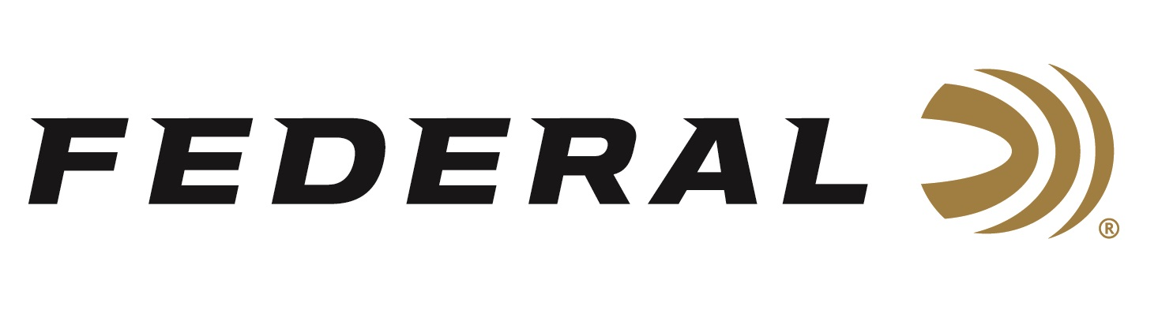

FOR IMMEDIATE RELEASE

Federal Will Launch More Than 130 New Products at the 2020 SHOT Show

ANOKA, Minnesota – January 10, 2020 – Federal, the largest ammunition manufacturer of the world, will announce an estimated total of 133 individual product SKUs in more than 34 cataloged product lines during the 2020 SHOT Show (Booth No. 14551), January 21-24 at the Sands Expo Center in Las Vegas, Nevada.

“This year, Federal has set a company record for the number of new loads and components introduced, and we are certainly quite proud of this accomplishment,” said Federal President Jason Vanderbrink. “Our manufacturing expertise, built over 98-years, means hunters and shooters of all stripes can get the new product that best meets their needs and interests.”

New for 2020 product launch highlights include:

Punch – This bullet’s skived jacket and soft lead core produce the best expansion and
penetration for the price. Nickel-plated brass and sealed primers deliver reliable
feeding and ignition. Available in 5 popular handgun options.

Terminal Ascent – Bonded construction penetrates deep, while the patented Slipstream polymer tip initiates expansion even at lower velocities and long range. AccuChannel groove technology improves accuracy and minimizes drag. Available in eleven of the most popular hunting cartridges and as component bullets.

Force X2 – Nine copper-plated 00 FX2 buckshot pellets split into two equal-size pieces on impact. Double the wound channels, improved energy transfer to the target, and less
potential for over-penetration.

MeatEater Series – Federal has partnered with conservationist, chef, author and hunter Steven Rinella on an exclusive new line of ammunition, featuring Trophy Copper rifle ammunition, 3rd Degree turkey loads and all-new Federal Premium Bismuth shotshells.

Hydra-Shok Deep 380 Auto – This line has been extended with the first expanding
380 Auto load to penetrate at least 12 inches in bare gel and through heavy clothing.

Solid Core – This deep-penetrating, hard bullet holds together while blowing through bone, and its Syntech jacket reduces friction and leading. Intended for hunting and protection against dangerous animals. Available in 6 offerings ranging from 9mm Luger to 44 Rem. Magnum.

Practice & Defend Packs – Convenient packs include 50 HST Personal Defense
loads and 50 ballistically identical Syntech Training Match rounds for the most realistic practice. Available in four product options.

Swift Scirocco II – High ballistic coefficients produce flat trajectories, while retaining more velocity and energy downrange. Available in nine loads from 243 Win. to 300 Win. Magnum.

6.5 PRC Gold Medal Berger Hybrid – The hot 6.5 PRC has joined the Gold Medal Berger line. The loads offer high ballistic coefficients and Gold Medal match primers.

“Being the largest ammunition manufacturer isn’t just boasting. It matters, because it allows Federal to deliver the widest range of new products to our customers every year,” said Vanderbrink. “Being the size we are means we can produce the quantity needed to fulfill military and law enforcement contracts, while also offering an unmatched variety to everyone—rimfire, shotshell, handgun and rifle ammo, as well as primers, cases and component bullets for reloaders.”

All these new products, and many more will be on display at Booth No. 14551 for customers to view and learn full details. Learn more at Federal and all its ammunition products visit: www.federalpremium.com.

Press Release Contact: JJ Reich
Senior Manager – Press Relations
E-mail: VistaPressroom@VistaOutdoor.com

About Federal Ammunition
Federal, headquartered in Anoka, MN, is a brand of Vista Outdoor Inc., an outdoor sports and recreation company. From humble beginnings nestled among the lakes and woods of Minnesota, Federal Ammunition has evolved into one of the world's largest producers of sporting ammunition. Beginning in 1922, founding president, Charles L. Horn, paved the way for our success. Today, Federal carries on Horn's vision for quality products and service with the next generation of outdoorsmen and women. We maintain our position as experts in the science of ammunition production. Every day we manufacture products to enhance our customers' shooting experience while partnering with the conservation organizations that protect and support our outdoor heritage. We offer thousands of options in our Federal Premium and Federal lines-it's what makes us the most complete ammunition company in the business and provides our customers with a choice no matter their pursuit.

